Model data with Power BI – Archived

Design a semantic model in Power BI

Introduction
Creating a great semantic model is one of the most important tasks that a data analyst can perform in Microsoft Power BI. By doing this job well, you help make it easier for people to understand your data, which will make building valuable Power BI reports easier for them and for you.
The pages in this module are instructional only, no data files are provided. You have a chance to work with real data in the labs.
A good semantic model offers the following benefits:
- Data exploration is faster.
- Aggregations are simpler to build.
- Reports are more accurate.
- Writing reports takes less time.
- Reports are easier to maintain in the future.
Providing set rules for what makes a good semantic model is difficult because all data is different, and the usage of that data varies. Generally, a smaller semantic model is better because it performs faster and will be simpler to use. However, defining what a smaller semantic model entails is equally as problematic because it's a heuristic and subjective concept.
Typically, a smaller semantic model is composed of fewer tables and fewer columns in each table that the user can see. If you import all necessary tables from a sales database, but the total table count is 30 tables, the user will not find that intuitive. Collapsing those tables into five tables make the semantic model more intuitive to the user, whereas if the user opens a table and finds 100 columns, they might find it overwhelming. Removing unneeded columns to provide a more manageable number increases the likelihood that the user reads all column names. To summarize, you should aim for simplicity when designing your semantic models.
The following image is an example semantic model. The boxes contain tables of data, where each line item within the box is a column. The lines that connect the boxes represent relationships between the tables. These relationships can be complex, even in such a simplistic model. The semantic model can become easily disorganized, and the total table count in the model can gradually increase. Keeping your semantic model simple, comprehensive, and accurate requires constant effort.
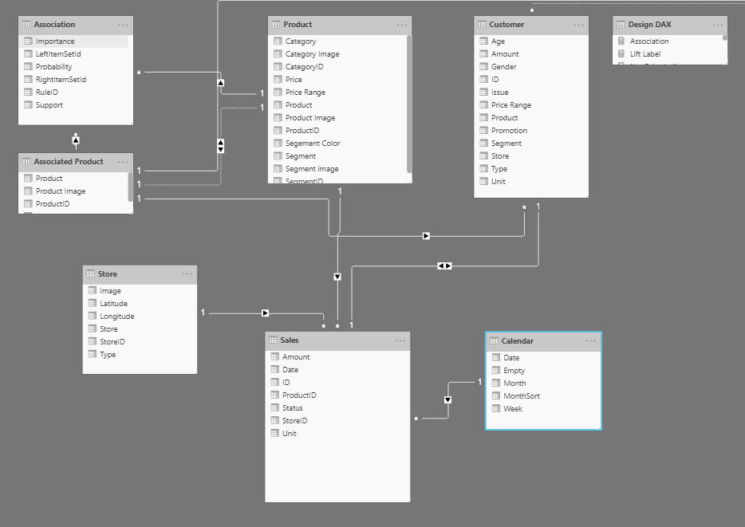
Relationships are defined between tables through primary and foreign keys. Primary keys are column(s) that identify each unique, non-null data row. For instance, if you have a Customers table, you could have an index that identifies each unique customer. The first row has an ID of 1, the second row an ID of 2, and so on. Each row is assigned a unique value, which can be referred to by this simple value: the primary key. This process becomes important when you are referencing rows in a different table, which is what foreign keys do. Relationships between tables are formed when you have primary and foreign keys in common between different tables.
Power BI allows relationships to be built from tables with different data sources, a powerful function that enables you to pull one table from Microsoft Excel and another from a relational database. You would then create the relationship between those two tables and treat them as a unified semantic model.
Now that you have learned about the relationships that make up the data schema, you are able to explore a specific type of schema design, the star schema, which is optimized for high performance and usability.

Star schemas
You can design a star schema to simplify your data. It's not the only way to simplify your data, but it is a popular method; therefore, every Power BI data analyst should understand it. In a star schema, each table within your semantic model is defined as a dimension or a fact table, as shown in the following visual.
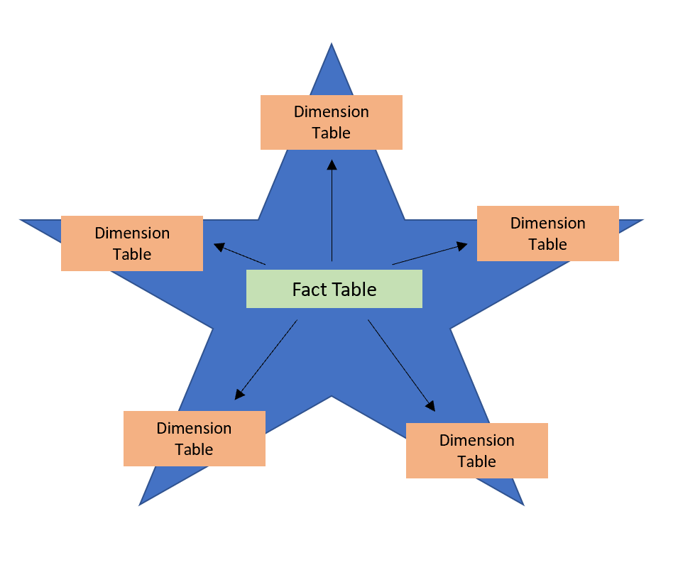
Fact tables contain observational or event data values: sales orders, product counts, prices, transactional dates and times, and quantities. Fact tables can contain several repeated values. For example, one product can appear multiple times in multiple rows, for different customers on different dates. These values can be aggregated to create visuals. For instance, a visual of the total sales orders is an aggregation of all sales orders in the fact table. With fact tables, it is common to see columns that are filled with numbers and dates. The numbers can be units of measurement, such as sale amount, or they can be keys, such as a customer ID. The dates represent time that is being recorded, like order date or shipped date.
Dimension tables contain the details about the data in fact tables: products, locations, employees, and order types. These tables are connected to the fact table through key columns. Dimension tables are used to filter and group the data in fact tables. The fact tables, on the other hand, contain the measurable data, such as sales and revenue, and each row represents a unique combination of values from the dimension tables. For the total sales orders visual, you could group the data so that you see total sales orders by product, in which product is data in the dimension table.
Fact tables are much larger than dimension tables because numerous events occur in fact tables, such as individual sales. Dimension tables are typically smaller because you are limited to the number of items that you can filter and group on. For instance, a year contains only so many months, and the United States are composed of only a certain number of states.
Considering this information about fact tables and dimension tables, you might wonder how you can build this visual in Power BI.
The pertinent data resides in two tables, Employee and Sales, as shown in the following semantic model. Because the Sales table contains the sales order values, which can be aggregated, it is considered a fact table. The Employee table contains the specific employee name, which filters the sales orders, so it would be a dimension table. The common column between the two tables, which is the primary key in the Employee table, is EmployeeID, so you can establish a relationship between the two tables based on this column.
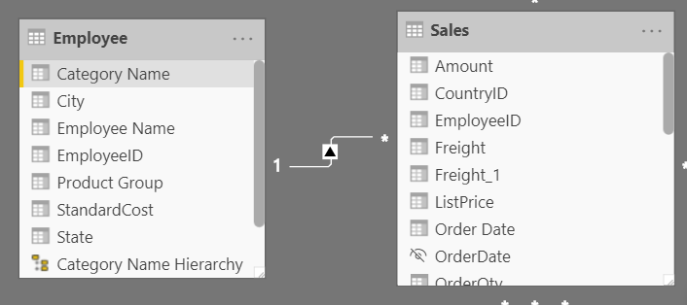
When creating this relationship, you can build the visual according to the requirements, as shown in the following figure. If you did not establish this relationship, while keeping in mind the commonality between the two tables, you would have had more difficulty building your visual.
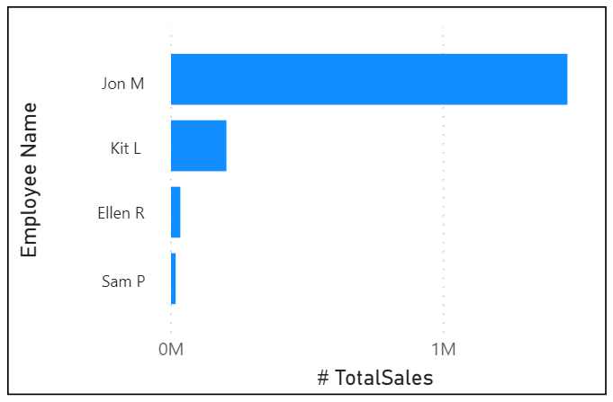
Star schemas and the underlying semantic model are the foundation of organized reports; the more time you spend creating these connections and design, the easier it will be to create and maintain reports.

Work with tables
When users see fewer tables, they will enjoy using your semantic model considerably more. For example, suppose you've imported dozens of tables from many data sources and now the visual appears disorderly. In this case, you need to ensure that, before you begin working on building reports, your semantic model and table structure are simplified.
A simple table structure will:
- Be simple to navigate because of column and table properties that are specific and user-friendly.
- Have merged or appended tables to simplify the tables within your data structure.
- Have good-quality relationships between tables that make sense.
The following sections further explain how you might work with your tables to ensure a simple and readable table structure.

Configure semantic model and build relationships between tables
Assuming that you've already retrieved your data and cleaned it in Power Query, you can then go to the Model tab, where the semantic model is located. The following image shows how the relationship between the Order and Sales tables can be seen through the OrderDate column.
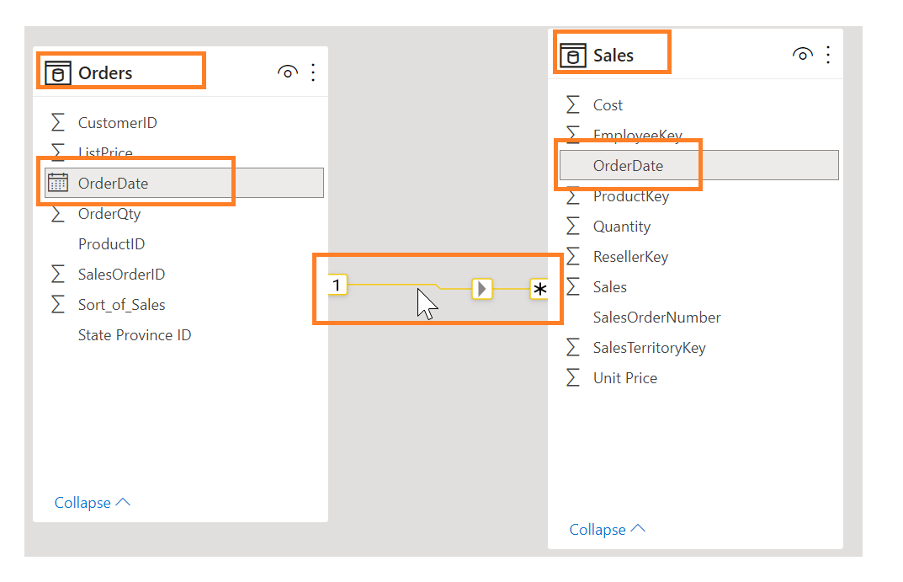
To manage these relationships, go to Manage Relationships on the ribbon, where the following window will appear.
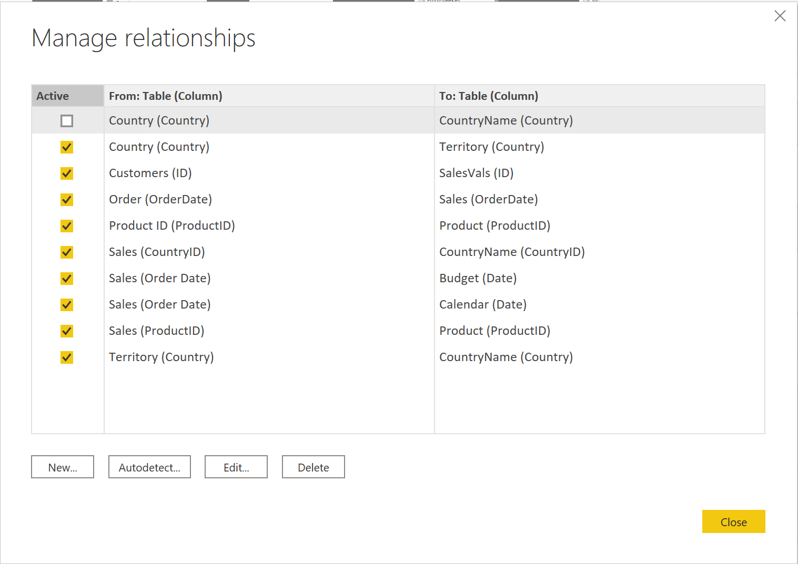
In this view, you can create, edit, and delete relationships between tables and also autodetect relationships that already exist. When you load your data into Power BI, the Autodetect feature will help you establish relationships between columns that are named similarly. Relationships can be inactive or active. Only one active relationship can exist between tables, which is discussed in a future module.
While the Manage Relationships feature allows you to configure relationships between tables, you can also configure table and column properties to ensure organization in your table structure.

Configure table and column properties
The Model view in Power BI desktop provides many options within the column properties that you can view or update. A simple method to get to this menu to update the tables and fields is by Ctrl+clicking or Shift+clicking items on this page.
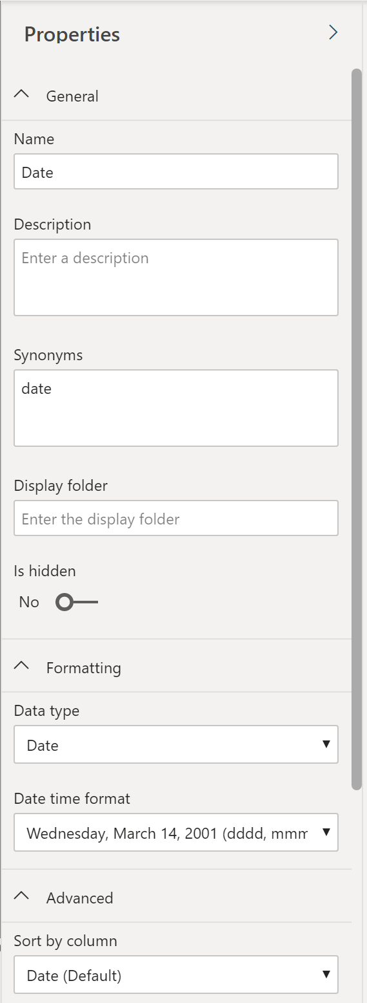
Under the General tab, you can:
- Edit the name and description of the column.
- Add synonyms that can be used to identify the column when you are using the Q&A feature.
- Add a column into a folder to further organize the table structure.
- Hide or show the column.
Under the Formatting tab, you can:
- Change the data type.
- Format the date.
For instance, suppose that the dates in your column are formatted, as seen in the previous screenshot, in the form of "Wednesday, March 14, 2001". If you want to change the format so that the date was in the "mm/dd/yyyy" format, you would select the drop-down menu under All date time formats and then choose the appropriate date format, as shown in the following figure.
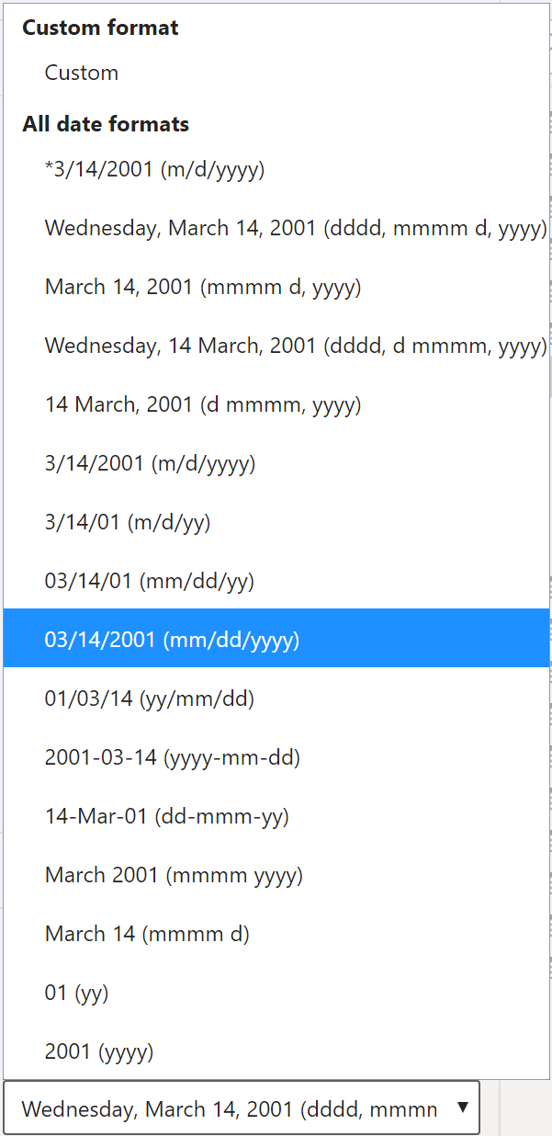
After selecting the appropriate date format, return to the Date column, where you should see that the format has indeed changed, as shown in the following figure.
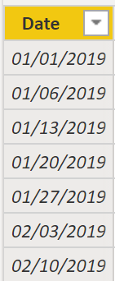
Under the Advanced tab, you can:
- Sort by a specific column.
- Assign a specific category to the data.
- Summarize the data.
- Determine if the column or table contains null values.
Additionally, Power BI has a new functionality to update these properties on many tables and fields by Ctrl+clicking or Shift+clicking items.
These examples are only some of the many types of transformations that you can make to simplify the table structure. This step is important to take before you begin making your visuals so that you don't have to go back and forth when making formatting changes. This process of formatting and configuring tables can also be done in Power Query.

Create a date table
During report creation in Power BI, a common business requirement is to make calculations based on date and time. Organizations want to know how their business is doing over months, quarters, fiscal years, and so on. For this reason, it is crucial that these time-oriented values are formatted correctly. Power BI autodetects for date columns and tables; however, situations can occur where you will need to take extra steps to get the dates in the format that your organization requires.
For example, suppose that you are developing reports for the Sales team at your organization. The database contains tables for sales, orders, products, and more. You notice that many of these tables, including Sales and Orders, contain their own date columns, as shown by the ShipDate and OrderDate columns in the Sales and Orders tables. You are tasked with developing a table of the total sales and orders by year and month. How can you build a visual with multiple tables, each referencing their own date columns?
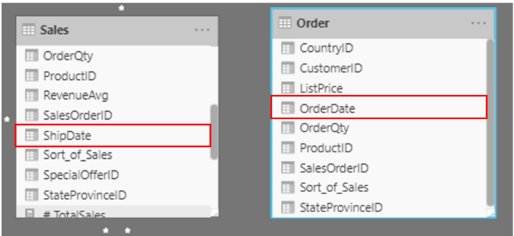
To solve this problem, you can create a common date table that can be used by multiple tables. The following section explains how you can accomplish this task in Power BI.

Create a common date table
Ways that you can build a common date table are:
- Source data
- DAX
- Power Query

Source data
Occasionally, source databases and data warehouses already have their own date tables. If the administrator who designed the database did a thorough job, these tables can be used to perform the following tasks:
- Identify company holidays
- Separate calendar and fiscal year
- Identify weekends versus weekdays
Source data tables are mature and ready for immediate use. If you have a table as such, bring it into your semantic model and don't use any other methods that are outlined in this section. We recommend that you use a source date table because it is likely shared with other tools that you might be using in addition to Power BI.
If you do not have a source data table, you can use other ways to build a common date table.

DAX
You can use the Data Analysis Expression (DAX) functions CALENDARAUTO() or CALENDAR() to build your common date table. The CALENDAR() function returns a contiguous range of dates based on a start and end date that are entered as arguments in the function. Alternatively, the CALENDARAUTO() function returns a contiguous, complete range of dates that are automatically determined from your semantic model. The starting date is chosen as the earliest date that exists in your semantic model, and the ending date is the latest date that exists in your semantic model plus data that has been populated to the fiscal month that you can choose to include as an argument in the CALENDARAUTO() function. For the purposes of this example, the CALENDAR() function is used because you only want to see the data from May 31, 2011 (the first day that Sales began its tracking of this data) and forward for the next 10 years.
In Power BI Desktop, select New Table, and then enter in the following DAX formula:
DAX
Dates = CALENDAR(DATE(2011, 5, 31), DATE(2022, 12, 31))
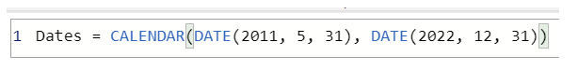
Now, you have a column of dates that you can use. However, this column is slightly sparse. You also want to see columns for just the year, the month number, the week of the year, and the day of the week. You can accomplish this task by selecting New Column on the ribbon and entering the following DAX equation, which will retrieve the year from your Date table.
DAX
Year = YEAR(Dates[Date])
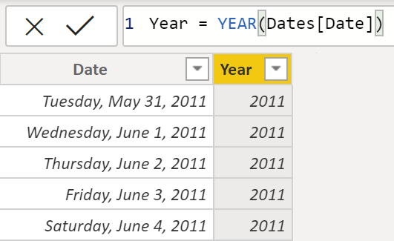
You can perform the same process to retrieve the month number, week number, and day of the week:
DAX
MonthNum = MONTH(Dates[Date])
DAX
WeekNum = WEEKNUM(Dates[Date])
DAX
DayoftheWeek = FORMAT(Dates[Date], "DDDD")
When you have finished, your table will contain the columns that are shown in the following figure.
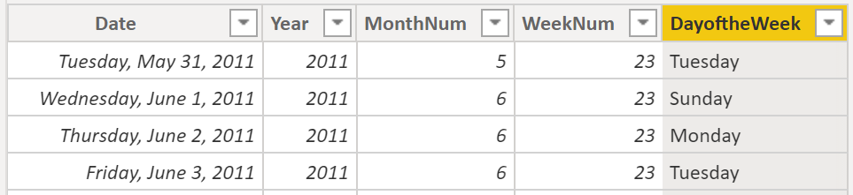
You have now created a common date table by using DAX. This process only adds your new table to the semantic model; you will still need to establish relationships between your date table and the Sales and Order tables, and then mark your table as the official date table of your semantic model. However, before you complete those tasks, make sure that you consider another way of building a common date table: by using Power Query.

Power Query
You can use M-language, the development language that is used to build queries in Power Query, to define a common date table.
Select Transform Data in Power BI Desktop, which will direct you to Power Query. In the blank space of the left Queries pane, right-click to open the following drop-down menu, where you will select New Query > Blank Query.
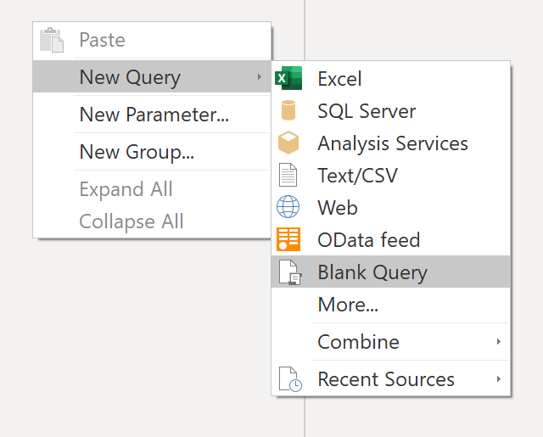
In the resulting New Query view, enter the following M-formula to build a calendar table:
M
= List.Dates(#date(2011,05,31), 365*10, #duration(1,0,0,0))
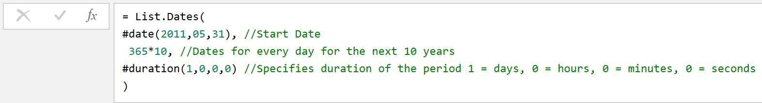
For your sales data, you want the start date to reflect the earliest date that you have in your data: May 31, 2011. Additionally, you want to see dates for the next 10 years, including dates in the future. This approach ensures that, as new sales data flows in, you won't have to re-create this table. You can also change duration. In this case, you want a data point for every day, but you can also increment by hours, minutes, and seconds. The following figure shows the result.
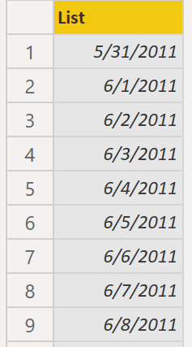
After you have realized success in the process, you notice that you have a list of dates instead of a table of dates. To correct this error, go to the Transform tab on the ribbon and select Convert > To Table. As the name suggests, this feature will convert your list into a table. You can also rename the column to DateCol.
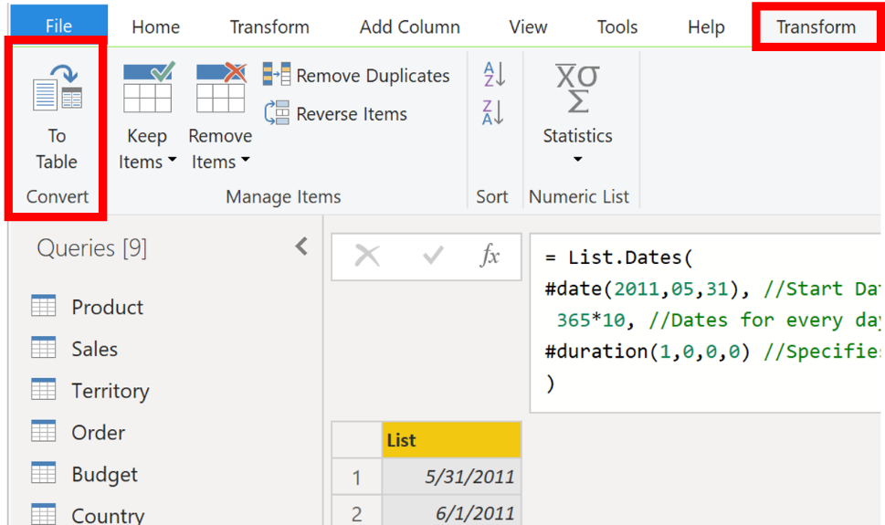
Next, you want to add columns to your new table to see dates in terms of year, month, week, and day so that you can build a hierarchy in your visual. Your first task is to change the column type by selecting the icon next to the name of the column and, in the resulting drop-down menu, selecting the Date type.
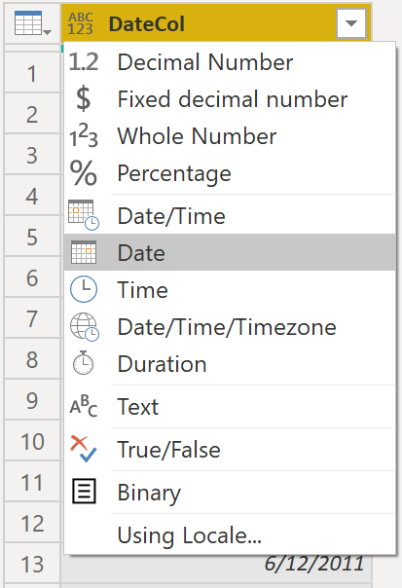
After you have finished selecting the Date type, you can add columns for year, months, weeks, and days. Go to Add Column, select the drop-down menu under Date, and then select Year, as shown in the following figure.
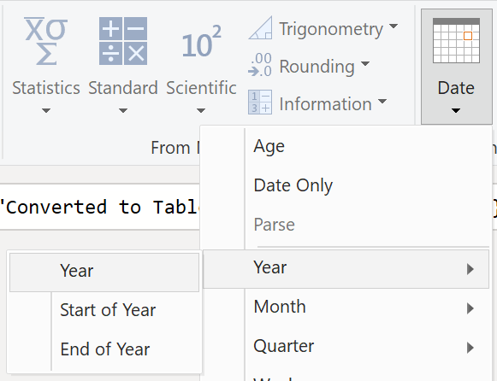
Notice that Power BI has added a column of all years that are pulled from DateCol.
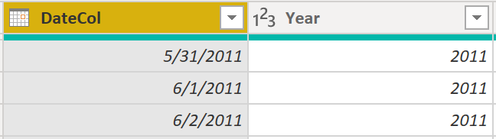
Complete the same process for months, weeks, and days. After you have finished this process, the table will contain the columns that are shown in the following figure.
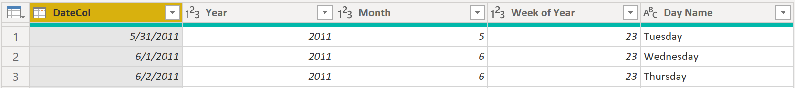
You have now successfully used Power Query to build a common date table.
The previous steps show how to get the table into the semantic model. Now, you need to mark your table as the official date table so that Power BI can recognize it for all future values and ensure that formatting is correct.

Mark as the official date table
Your first task in marking your table as the official date table is to find the new table on the Fields pane. Right-click the name of the table and then select Mark as date table, as shown in the following figure.
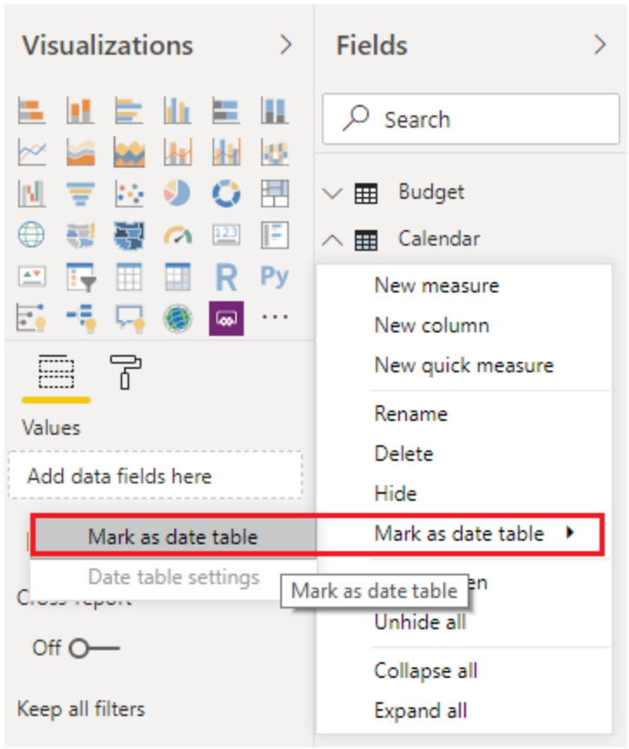
By marking your table as a date table, Power BI performs validations to ensure that the data contains zero null values, is unique, and contains continuous date values over a period. You can also choose specific columns in your table to mark as the date, which can be useful when you have many columns within your table. Right-click the table, select Mark as date table, and then select Date table settings. The following window will appear, where you can choose which column should be marked as Date.
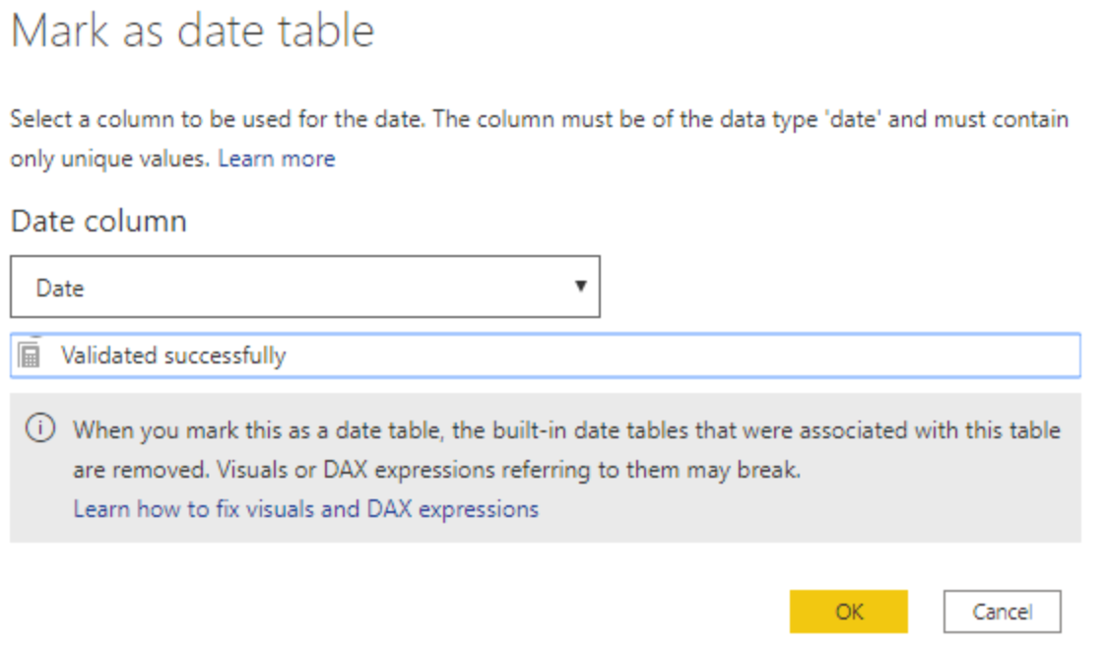
Selecting Mark as date table will remove autogenerated hierarchies from the Date field in the table that you marked as a date table. For other date fields, the auto hierarchy will still be present until you establish a relationship between that field and the date table or until you turn off the Auto Date/Time feature. You can manually add a hierarchy to your common date table by right-clicking the year, month, week, or day columns in the Fields pane and then selecting New hierarchy. This process is further discussed later in this module.

Build your visual
To build your visual between the Sales and Orders tables, you will need to establish a relationship between this new common date table and the Sales and Orders tables. As a result, you will be able to build visuals by using the new date table. To complete this task, go to Model tab > Manage Relationships, where you can create relationships between the common date table and the Orders and Sales tables by using the OrderDate column. The following screenshot shows an example of one such relationship.
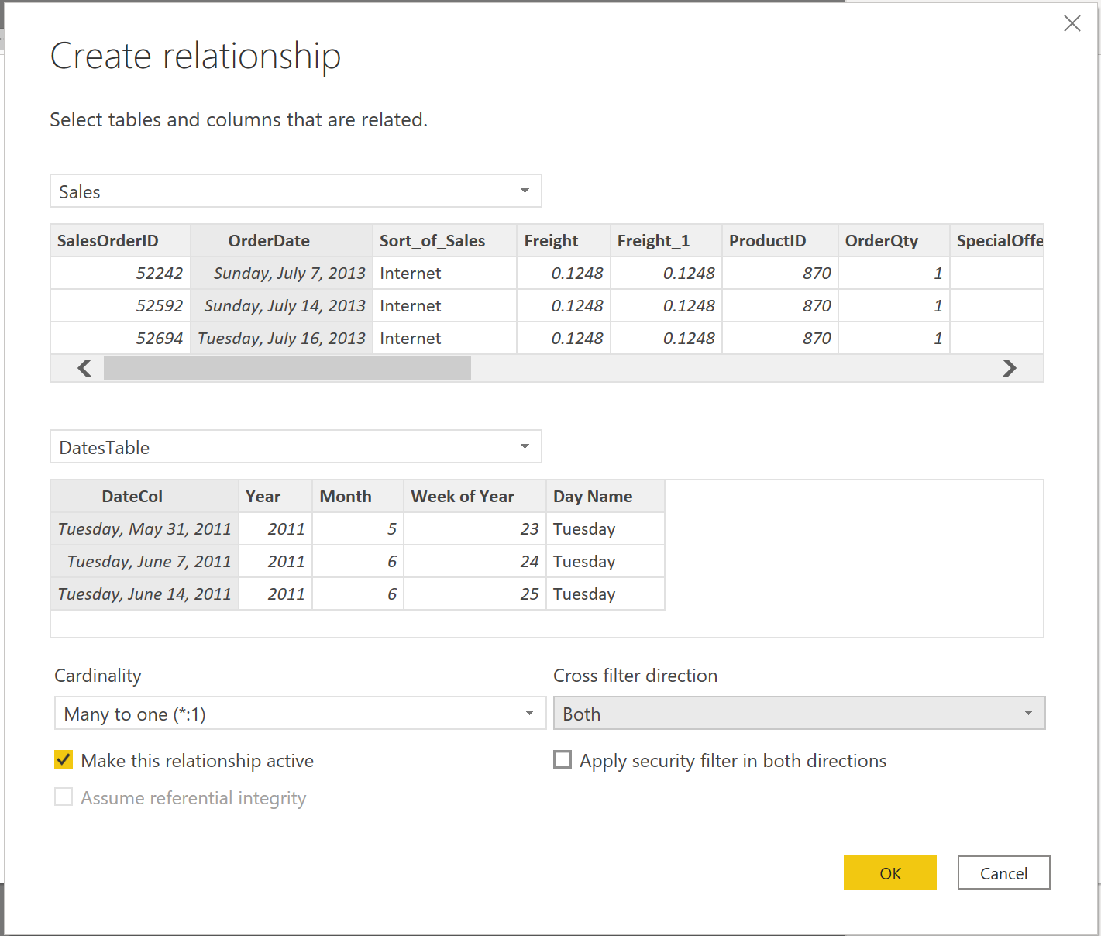
After you have built the relationships, you can build your Total Sales and Order Quantity by Time visual with your common date table that you developed by using the DAX or Power Query method.
To determine the total sales, you need to add all sales because the Amount column in the Sales table only looks at the revenue for each sale, not the total sales revenue. You can complete this task by using the following measure calculation, which will be explained in later discussions. The calculation that you will use when building this measure is as follows:
DAX
#Total Sales = SUM(Sales[‘Amount’])
After you have finished, you can create a table by returning to the Visualizations tab and selecting the Table visual. You want to see the total orders and sales by year and month, so you only want to include the Year and Month columns from your date table, the OrderQty column, and the #TotalSales measure. When you learn about hierarchies, you can also build a hierarchy that will allow you drill down from years to months. For this example, you can view them side-by-side. You have now successfully created a visual with a common date table.
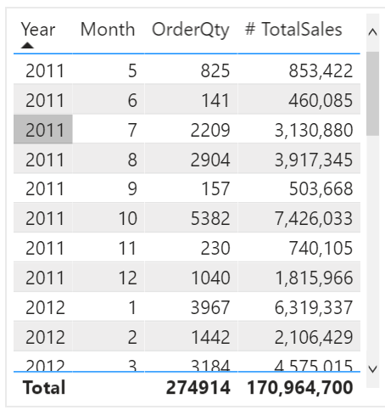

Work with dimensions
When building a star schema, you will have dimension and fact tables. Fact tables contain information about events such as sales orders, shipping dates, resellers, and suppliers. Dimension tables store details about business entities, such as products or time, and are connected back to fact tables through a relationship.
You can use hierarchies as one source to help you find detail in dimension tables. These hierarchies form through natural segments in your data. For instance, you can have a hierarchy of dates in which your dates can be segmented into years, months, weeks, and days. Hierarchies are useful because they allow you to drill down into the specifics of your data instead of only seeing the data at a high level.

Hierarchies
When you are building visuals, Power BI automatically enters values of the date type as a hierarchy (if the table has not been marked as a date table).
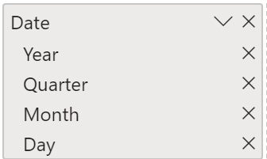
In the preceding Date column, the date is shown in increasingly finer detail through year, quarters, months, and days. You can also manually create hierarchies.
For example, consider a situation where you want to create a stacked bar chart of Total Sales by Category and Subcategory. You can accomplish this task by creating a hierarchy in the Product table for categories and subcategories. To create a hierarchy, go to the Fields pane on Power BI and then right-click the column that you want the hierarchy for. Select New hierarchy, as shown in the following figure.
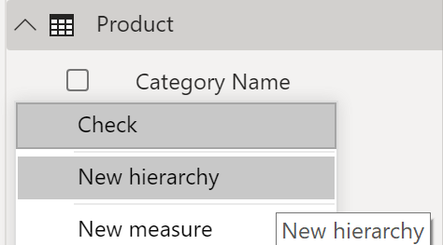
Next, drag and drop the subcategory column into this new hierarchy that you've created. This column will be added as a sublevel on the hierarchy.
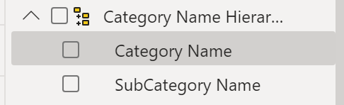
Now, you can build the visual by selecting a stacked bar chart in the Visualizations pane. Add your Category Name Hierarchy in the Axis field and Total Sales in the Values field.
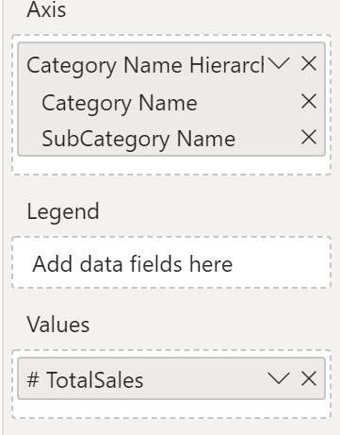
You can drill down on the visual to view both Category and Subcategory, depending on what you want to see. Hierarchies allow you to view increasing levels of data on a single view.
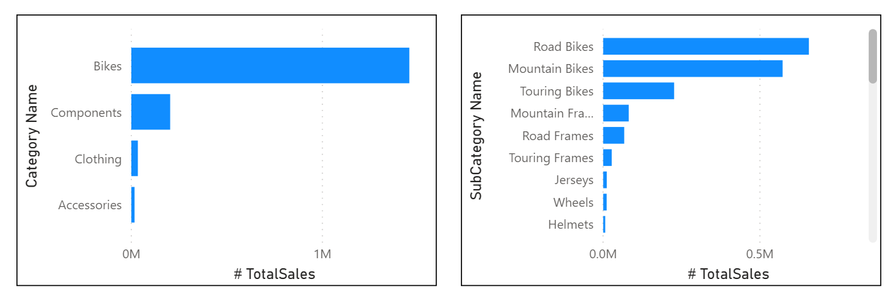
Now that you have learned about hierarchies, you can take a step further and examine parent-child hierarchies and their role in multiple relationships between fact tables and dimension tables.

Parent-child hierarchy
In the following example, you have an Employee table within the database that tells you important information about the employees, their managers, and their IDs. When looking at this table, you notice that Roy F has been repeated multiple times in the Manager column. As the image shows, multiple employees can have the same manager, which indicates a hierarchy between managers and employees.
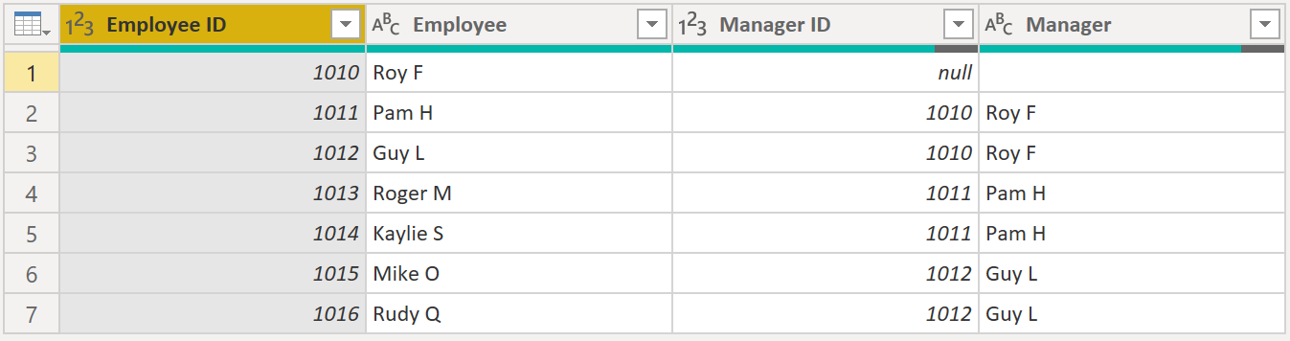
The Manager column determines the hierarchy and is therefore the parent, while the "children" are the employees. For this example, you want to be able to see all levels of this hierarchy. Power BI does not default to showing you all levels of the hierarchy, so it is your responsibility to ensure that you see all levels of this hierarchy or "flatten" it so that you can see more data granularity.

Flatten parent-child hierarchy
The process of viewing multiple child levels based on a top-level parent is known as flattening the hierarchy. In this process, you are creating multiple columns in a table to show the hierarchical path of the parent to the child in the same record. You will use PATH(), a simple DAX function that returns a text version of the managerial path for each employee, and PATHITEM() to separate this path into each level of managerial hierarchy.
Important
DAX has not been covered yet; however, it will be in another module. This function is included in this section because it's explaining hierarchies. If use of DAX in this capacity is confusing, refer to the DAX module and then return to this section afterward.
While on the table, go to the Modeling tab and select New Column. In the resulting formula bar, enter the following function, which creates the text path between the employee and manager. This action creates a calculated column in DAX.
DAX
Path = PATH(Employee[Employee ID], Employee[Manager ID])
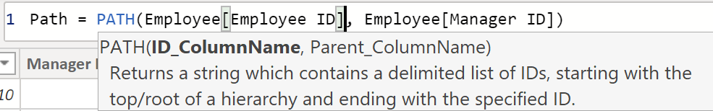
The completed path between the employee and the manager appears in the new column, as shown in the following screenshot.
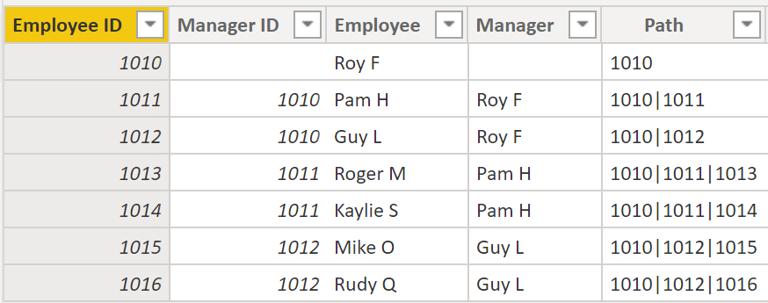
If you look at Roger M, the path of IDs is 1010 | 1011 | 1013, which means that one level above Roger M (ID 1013) is his manager, Pam H (ID 1011), and one level above Pam H is her manager Roy F (ID 1010). In this row, Roger M is on the bottom of the hierarchy, at the child level, and Roy F is at the top of the hierarchy and is at the parent level. This path is created for every employee. To flatten the hierarchy, you can separate each level by using the PATHITEM function.
To view all three levels of the hierarchy separately, you can create four columns in the same way that you did previously, by entering the following equations. You will use the PATHITEM function to retrieve the value that resides in the corresponding level of your hierarchy.
Level 1 = PATHITEM(Employee[Path],1)
Level 2 = PATHITEM(Employee[Path],2)
Level 3 = PATHITEM(Employee[Path],3)
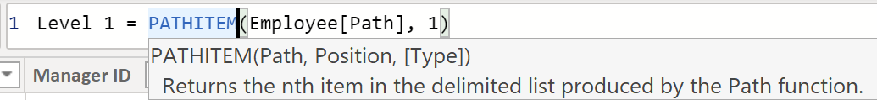
After you have finished, notice that you now have each level of hierarchy within your table. Roy F is at the top of the hierarchy and, as you go through Levels 2-3, notice that the managers and employees map with each other.
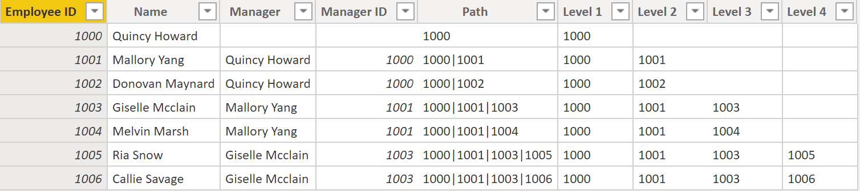
Now, you can create a hierarchy on the Fields pane, as you did previously. Right-click Level 1, because this is the first hierarchy level, and then select New Hierarchy. Then, drag and drop Level 2 and Level 3 into this hierarchy.
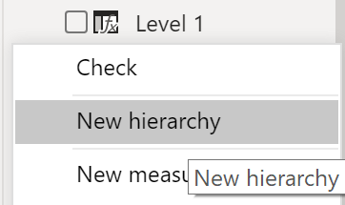
You have now successfully flattened a hierarchy so that you can view individual levels.
Previously, you've considered dimensions that have only one relationship with a fact table. However, situations do occur where your dimension table will have multiple relationships with a fact table.

Role-playing dimensions
Role-playing dimensions have multiple valid relationships with fact tables, meaning that the same dimension can be used to filter multiple columns or tables of data. As a result, you can filter data differently depending on what information you need to retrieve. This topic is complex, so it is only introduced in this section. Working with role-playing dimensions requires complex DAX functions that will be discussed in later sections.
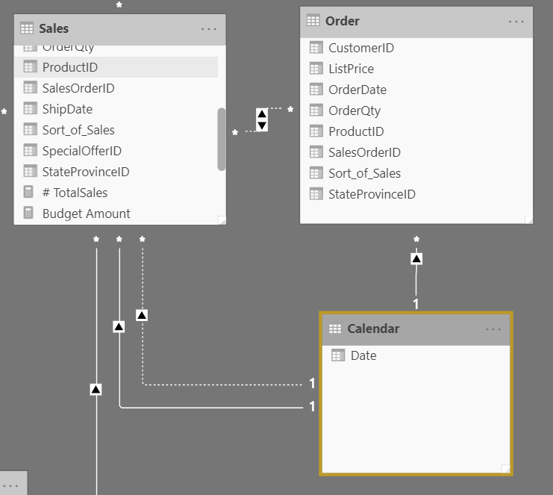
The preceding visual shows the Calendar, Sales, and Order tables. Calendar is the dimension table, while Sales and Order are fact tables. The dimension table has two relationships: one with Sales and one with Order. This example is of a role-playing dimension because the Calendar table can be used to group data in both Sales and Order. If you wanted to build a visual in which the Calendar table references the Order and the Sales tables, the Calendar table would act as a role-playing dimension.

Define data granularity
Data granularity is the detail that is represented within your data, meaning that the more granularity your data has, the greater the level of detail within your data.
Data granularity is an important topic for all data analysts, regardless of the Power BI tools that you're using. Defining the correct data granularity can have a big impact on the performance and usability of your Power BI reports and visuals.

Data granularity defined
Consider a scenario where your company manages 1,000 refrigerated semi-trucks. Every few minutes, each truck uses a Microsoft Azure IoT application to record its current temperature. This temperature is important to your organization because, if the refrigeration were to malfunction, it could spoil the entire load, costing thousands of dollars. With so many trucks and so many sensors, extensive data is generated every day. Your report users don't want to sift through numerous records to find the ones that they are particularly interested in.
How can you change the granularity of the data to make the semantic model more usable?
In this scenario, you might want to import the data by using a daily average for each truck. That approach would reduce the records in the database to one record for each truck for each day. If you decide that the approach was acceptable enough for tracking costs and errors, then you could use that data granularity. Alternatively, you could select the last recorded temperature, or you could only import records that are above or below a normal range of temperatures. Any of these methods will reduce the total records that you import, while still bringing in data that is comprehensive and valuable.
For different scenarios, you could settle on data granularity that is defined weekly, monthly, or quarterly. Generally, the fewer the records that you are working with, the faster your reports and visuals will function. This approach translates to a faster refresh rate for the entire semantic model, which might mean that you can refresh more frequently.
However, that approach has a drawback. If your users want to drill into every single transaction, summarizing the granularity will prevent them from doing that, which can have a negative impact on the user experience. It is important to negotiate the level of data granularity with report users so they understand the implications of these choices.

Change data granularity to build a relationship between two tables
Data granularity can also have an impact when you're building relationships between tables in Power BI.
For example, consider that you're building reports for the Sales team at Tailwind Traders. You've been asked to build a matrix of total sales and budget over time by using the Calendar, Sales, and Budget tables. You notice that the lowest level of time-based detail that the Sales table goes into is by day, for instance 5/1/2020, 6/7/2020, and 6/18/2020. The Budget table only goes to the monthly level, for instance, the budget data is 5/2020 and 6/2020. These tables have different granularities that need to be reconciled before you can build a relationship between tables.
The following figure shows your current semantic model.
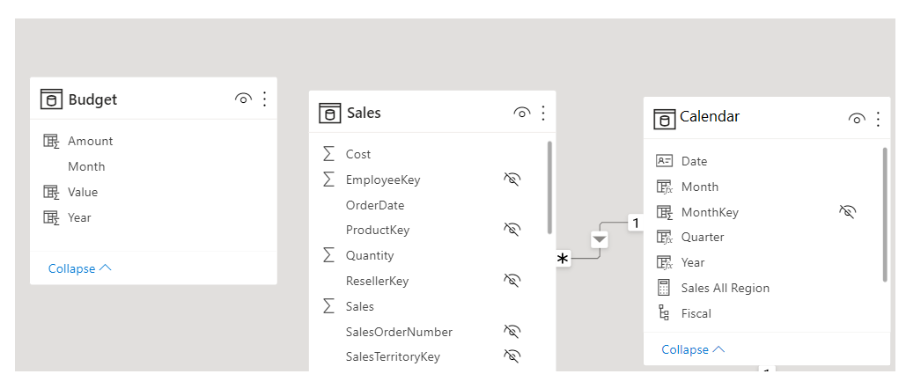
As shown in the preceding figure, a relationship between Budget and Calendar is missing. Therefore, you need to create this relationship before you can build your visual. Notice that if you transform the Year and Month columns in the Calendar table into a new column, and do the same transformation in the Budget table, you can match the format of the Date column in the Calendar table. Then, you can establish a relationship between the two columns. To complete this task, you'll concatenate the Year and Month columns and then change the format.
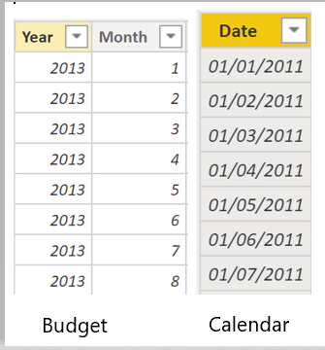
Select Transform Data on the ribbon. On Applied Steps, on the right pane, right-click the last step and then select Insert Step After.
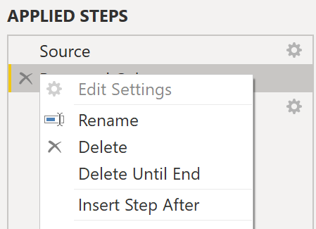
Under Add Column on the Home ribbon, select Custom Column. Enter the following equation, which will concatenate the Year and Month columns, and then add a dash in between the column names.
M
Column = Table.AddColumn(#"Renamed Columns", "Custom", each [Year] & "-" &[Month])
Change the data type to Date and then rename the column. Your Budget table should resemble the following figure.
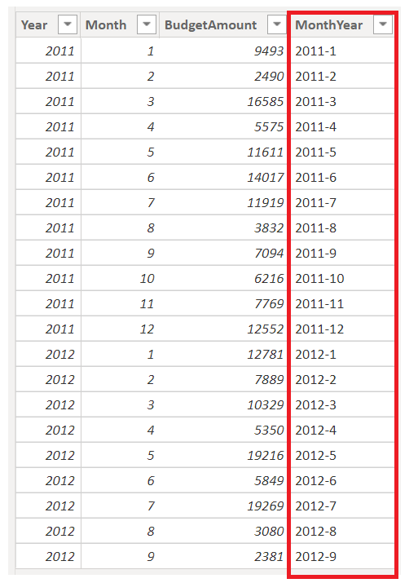
Now, you can create a relationship between the Budget and the Calendar tables.

Create a relationship between tables
Power BI automatically detects relationships, but you can also go to Manage Relationships > New and create the relationship on the Date column. The relationship should resemble the following figure.
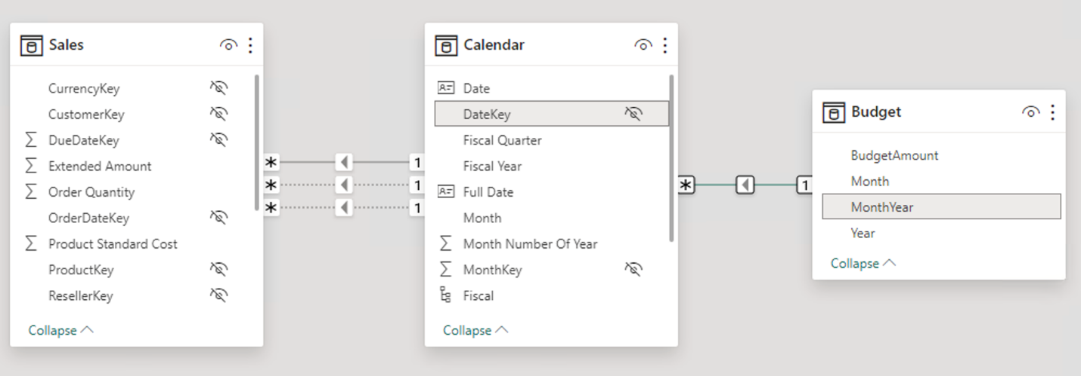
By completing this task, you've ensured that the granularity is the same between your different tables. Now, you need to create DAX measures to calculate Total Sales and BudgetAmount. Go to the Data pane on Power BI Desktop, select New Measure, and then create two measures with the following equations:
DAX
TotalSales = SUM(Sales[Total Sales])
DAX
BudgetAmount = SUM (Budget[BudgetAmount])
Select the table visual on the Visualization pane, and then enter these measures and the Date into the Values field. You've now accomplished the goal of building a matrix of the total sales and budgets over time.
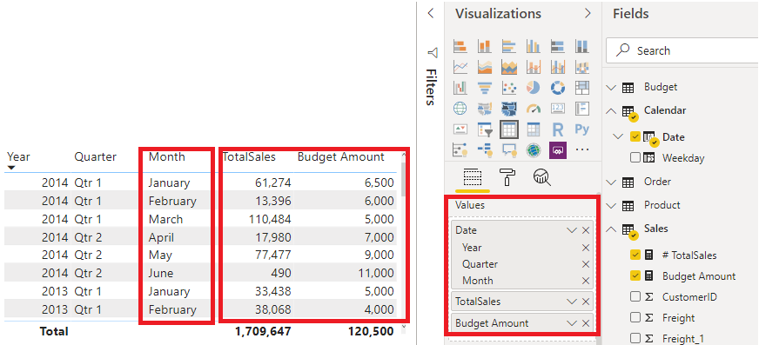

Work with relationships and cardinality
Unlike other database management systems, Power BI has the concept of directionality to a relationship. This directionality plays an important role in filtering data between multiple tables. When you load data, Power BI automatically looks for relationships that exist within the data by matching column names. You can also use Manage Relationships to edit these options manually.
For example, you've retrieved many tables from the Sales database, and the following image is an example of your semantic model. Power BI has autodetected several relationships, but you can't discern what they mean. You want to make sure that the relationships accurately reflect those that exist in your data.
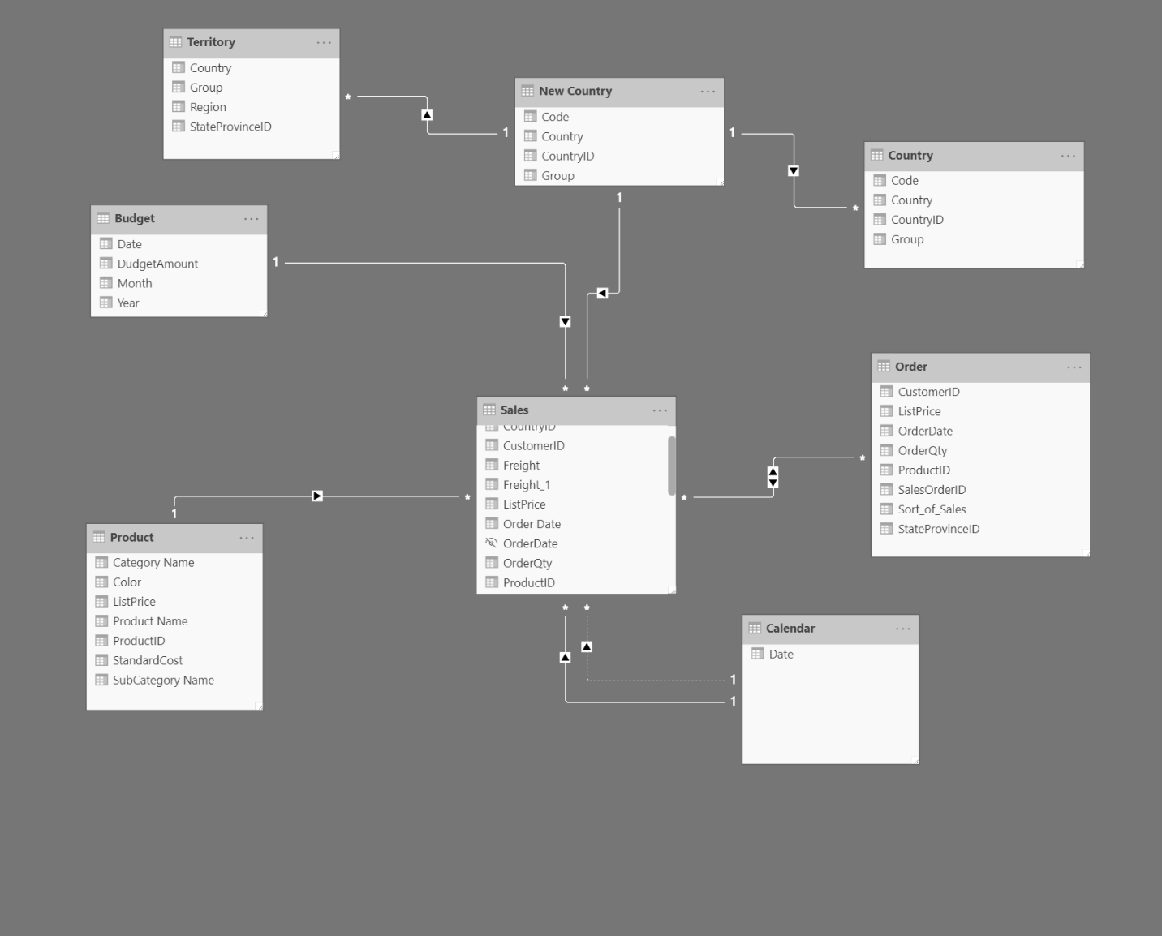

Relationships
The following are different types of relationships that you'll find in Power BI.
Many-to-one (*:1) or one-to-many (1: *) relationship
- Describes a relationship in which you have many instances of a value in one column that are related to only one unique corresponding instance in another column.
- Describes the directionality between fact and dimension tables.
- Is the most common type of directionality and is the Power BI default when you are automatically creating relationships.
An example of a one-to-many relationship would be between the CountryName and Territory tables, where you can have many territories that are associated with one unique country/region.
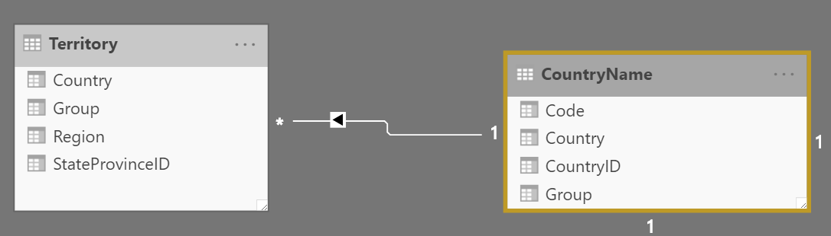
One-to-one (1:1) relationship:
- Describes a relationship in which only one instance of a value is common between two tables.
- Requires unique values in both tables.
- Is not recommended because this relationship stores redundant information and suggests that the model is not designed correctly. It is better practice to combine the tables.
An example of a one-to-one relationship would be if you had products and product IDs in two different tables. Creating a one-to-one relationship is redundant and these two tables should be combined.
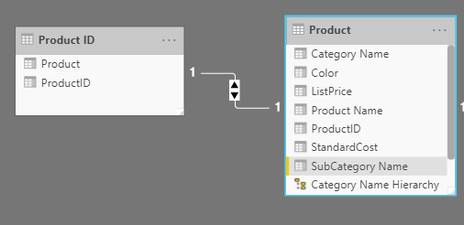
Many-to-many (.) relationship:
- Describes a relationship where many values are in common between two tables.
- Does not require unique values in either table in a relationship.
- Is not recommended; a lack of unique values introduces ambiguity and your users might not know which column of values is referring to what.
For instance, the following figure shows a many-to-many relationship between the Sales and Order tables on the OrderDate column because multiple sales can have multiple orders associated with them. Ambiguity is introduced because both tables can have the same order date.
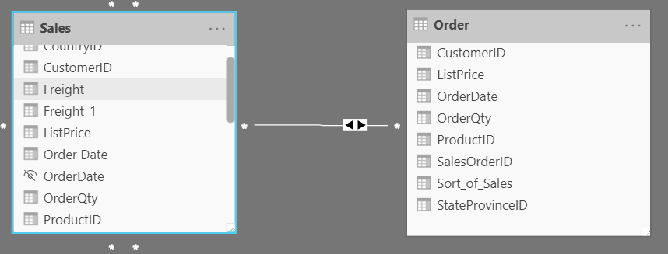

Cross-filter direction
Data can be filtered on one or both sides of a relationship.
With a single cross-filter direction:
- Only one table in a relationship can be used to filter the data. For instance, Table 1 can be filtered by Table 2, but Table 2 cannot be filtered by Table 1.
Tip
Follow the direction of the arrow on the relationship between your tables to know which direction the filter will flow. You typically want these arrows to point to your fact table.
- For a one-to-many or many-to-one relationship, the cross-filter direction will be from the "one" side, meaning that the filtering will occur in the table that has many values.
With both cross-filter directions or bi-directional cross-filtering:
- One table in a relationship can be used to filter the other. For instance, a dimension table can be filtered through the fact table, and the fact tables can be filtered through the dimension table.
- You might have lower performance when using bi-directional cross-filtering with many-to-many relationships.
A word of caution regarding bi-directional cross-filtering: You should not enable bi-directional cross-filtering relationships unless you fully understand the ramifications of doing so. Enabling it can lead to ambiguity, over-sampling, unexpected results, and potential performance degradation.

Cardinality and cross-filter direction
For one-to-one relationships, the only option that is available is bi-directional cross-filtering. Data can be filtered on either side of this relationship and result in one distinct, unambiguous value. For instance, you can filter on one Product ID and be returned a single Product, and you can filter on a Product and be returned a single Product ID.
For many-to-many relationships, you can choose to filter in a single direction or in both directions by using bi-directional cross-filtering. The ambiguity that is associated with bi-directional cross-filtering is amplified in a many-to-many relationship because multiple paths will exist between different tables. If you create a measure, calculation, or filter, unintended consequences can occur where your data is being filtered and, depending on which relationship that the Power BI engine chooses when applying the filter, the final result might be different. This situation is also true for bi-directional relationships and why you should be cautious when using them.
For this reason, many-to-many relationships and/or bi-directional relationships are complicated. Unless you are certain what your data looks like when aggregated, these types of open-ended relationships with multiple filtering directions can introduce multiple paths through the data.

Create many-to-many relationships
Consider the scenario where you are tasked with building a visual that examines budgets for customers and accounts. You can have multiple customers on the same account and multiple accounts with the same customer, so you know that you need to create a many-to-many relationship.
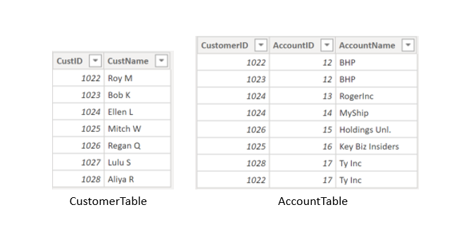
To create this relationship, go to Manage Relationships > New. In the resulting window, create a relationship between the Customer ID column in CustomerTable and AccountTable. The relationship is set to many-to-many, and the filter type is in both directions. Immediately, you will be warned that you should only use this type of relationship if it is expected that neither column will have unique values because you might get unexpected values. Because you want to filter in both directions, choose bi-directional cross-filtering.
Select OK. You have now successfully created a many-to-many relationship.
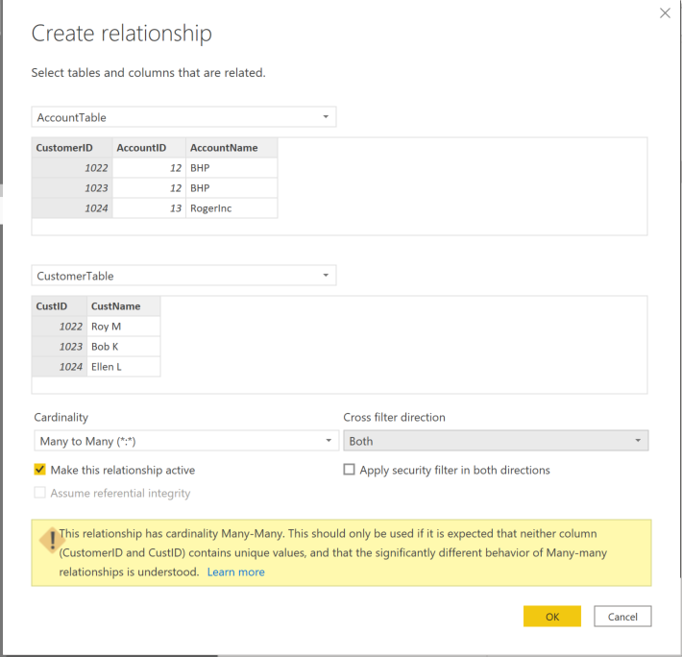

Resolve modeling challenges
Modeling data is about establishing and maintaining relationships so that you can effectively visualize the data in the form that your business requires. When you are creating these relationships, a common pitfall that you might encounter are circular relationships.
For example, you are developing reports for the Sales team and are examining the relationships between tables. In a poorly designed semantic model, Table 1 has a many-to-one relationship with a column in Table 2, but Table 2 has a one-to-many relationship with Table 3 that has its own relationship with Table 1. This web of relationships is difficult to manage and becomes a daunting task to build visuals because it is no longer clear what relationships exist. Therefore, it is important that you are able to identify circular relationships so that your data is usable.

Relationship dependencies
To understand circular relationships, you first need to understand dependencies.
For example, consider that you have the following calculated column Total in the Sales table.
Sales[‘TotalCost’] = Sales[‘Quantity’] * Sales[‘Price’]
TotalCost depends on Quantity and Price, so if a change occurs in either quantity or price, a change will occur in TotalCost as well. This example outlines a dependency of a column on other columns, but you can also have dependencies between measures, tables, and relationships.
Consider the following relationships between dSalesPerson, fSales, and dCustomer. A change in dCustomer will result in a change in fSales, which results in changes in dSalesPerson. These types of dependencies can exist within relationships.
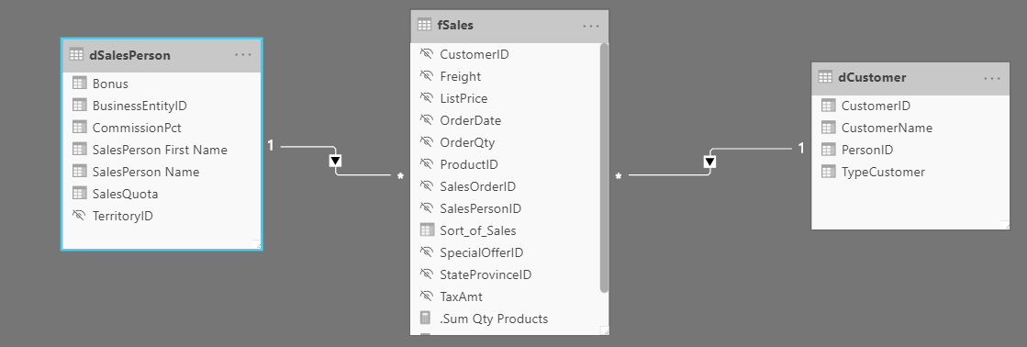

Exercise - Design a Data Model in Power BI

Lab story
In this lab, you’ll commence developing the data model. It will involve creating relationships between tables, and then configuring table and column properties to improve the friendliness and usability of the data model. You’ll also create hierarchies and create quick measures.
In this lab you learn how to:
- Create model relationships
- Configure table and column properties
- Create hierarchies
This lab should take approximately 45 minutes.

Get started
To complete this exercise, first open a web browser and enter the following URL to download the zip folder:
https://github.com/MicrosoftLearning/PL-300-Microsoft-Power-BI-Data-Analyst/raw/Main/Allfiles/Labs/03-configure-data-model-in-power-bi-desktop/03-model-data.zip
Extract the folder to the C:\Users\Student\Downloads\03-model-data folder.
Open the 03-Starter-Sales Analysis.pbix file.
Note: You can dismiss the sign-in by selecting Cancel. Close any other informational windows. Select Apply Later, if prompted to apply changes.

Create model relationships
In this task, you’ll create model relationships. The file was configured to not identify relationships between tables, which isn’t the default setting, but is recommended to prevent extra work creating the correct relationships for your model.
Important: The labs use a shorthand notation to reference a field. It will look like this: Product | Category. In this example, Product is the table name and Category is the field name.
- In Power BI Desktop, at the left, select the Report view icon.
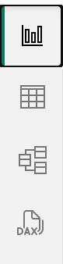
- To view all table fields, in the Data pane, right-click an empty area, and then select Expand All.
- To create a table visual, in the Data pane, from inside the Product table, check the Category field.
- To add another column to the table, in the Data pane, check the Sales | Sales field.
- Notice that the table visual lists four product categories, and that the sales value is the same for each, and the same for the total.
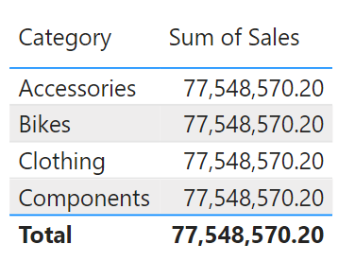
The issue is that the table is based on fields from different tables. The expectation is that each product category displays the sales for that category. However, because there isn’t a model relationship between these tables, the Sales table isn’t filtered. You’ll now add a relationship to propagate filters between the tables.
- Select the Model view icon from the left navigation pane, and select Manage Relationships.
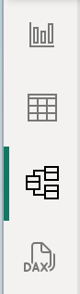
- In the Manage Relationships window, notice that no relationships are yet defined. To create a relationship, select New relationship.
- Configure the relationship from Product table to Sales table. Notice the following elements were automatically configured:
  - ProductKey columns in each table are selected. The columns were selected because they share the same name and data type. You may need to find matching columns with different names in real data.
  - Cardinality type is One To Many (1:*). The cardinality was automatically detected, because Power BI understands that the ProductKey column from the Product table contains unique values. One-to-many relationships are the most common cardinality, and all relationship you create in this lab will be this type.
  - Cross Filter Direction type is Single. Single filter direction means that filters propagate from the “one side” to the “many side”. In this case, it means filters applied to the Product table will propagate to the Sales table, but not in the opposite direction.
  - Make This Relationship Active is checked. Active relationships propagate filters. It’s possible to mark a relationship as inactive so filters don’t propagate. Inactive relationships can exist when there are multiple relationship paths between tables. In this case, model calculations can use special functions to activate them.
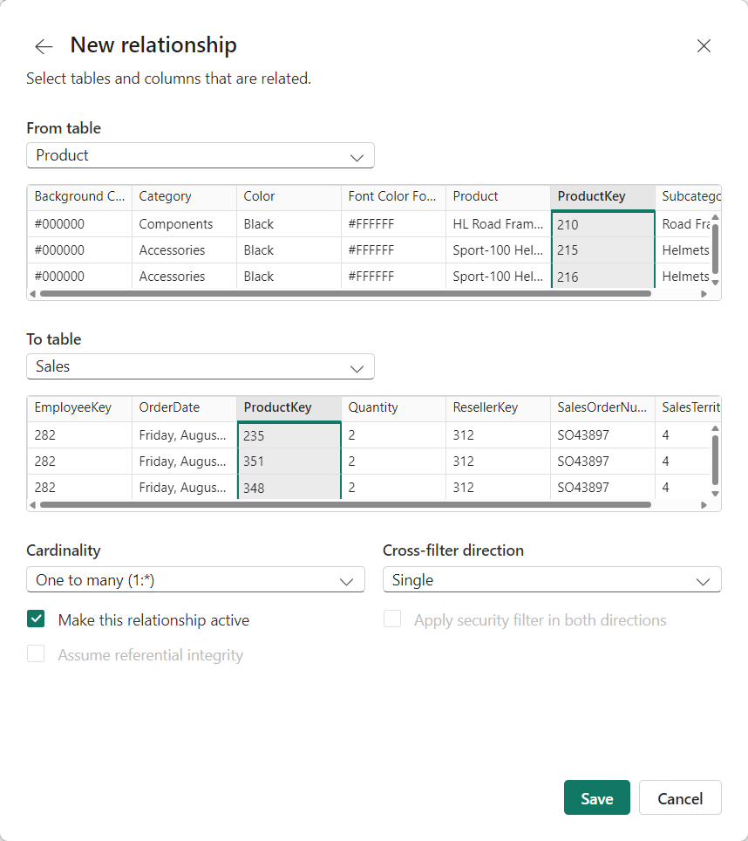
- Select OK, notice in the Manage Relationships window that the new relationship is listed, and then select Close.
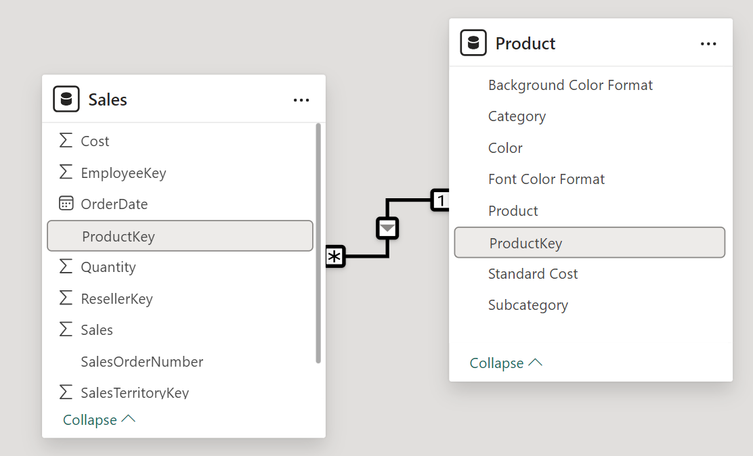
Notice there’s now a connector between the two tables (it doesn’t matter if the tables are positioned next to each other). - You can interpret the cardinality that is represented by the 1 and (*) indicators. - Filter direction is represented by the arrow head. - A solid line represents an active relationship; a dashed line represents an inactive relationship. - Hover the cursor over the relationship to highlight the related columns.

Create additional relationships
There’s an easier way to create a relationship. In the model diagram, you can drag and drop columns to create a new relationship.
- To create a new relationship using a different technique, from the Reseller table, drag the ResellerKey column onto the ResellerKey column of the Sales table.
Tip: Sometime a column doesn’t want to be dragged. If this situation arises, select a different column, and then select the column you intend to drag again, and then try again. Ensure that you see the new relationship added to the diagram.
![Drag ResellerKey from Reseller table onto Sales | ResellerKey](/PL-300-Microsoft-Power-BI-Data-Analyst/Instructions/Labs/Linked_image_Files/03-drag-relationship.png)
- Use the new technique to create the following two model relationships:
  - Region | SalesTerritoryKey to Sales | SalesTerritoryKey
  - Salesperson | EmployeeKey to Sales | EmployeeKey
- In the diagram, arrange the tables so that the Sales table is positioned in the center of the diagram, and the related tables are arranged about it. Position the disconnected tables to the side.
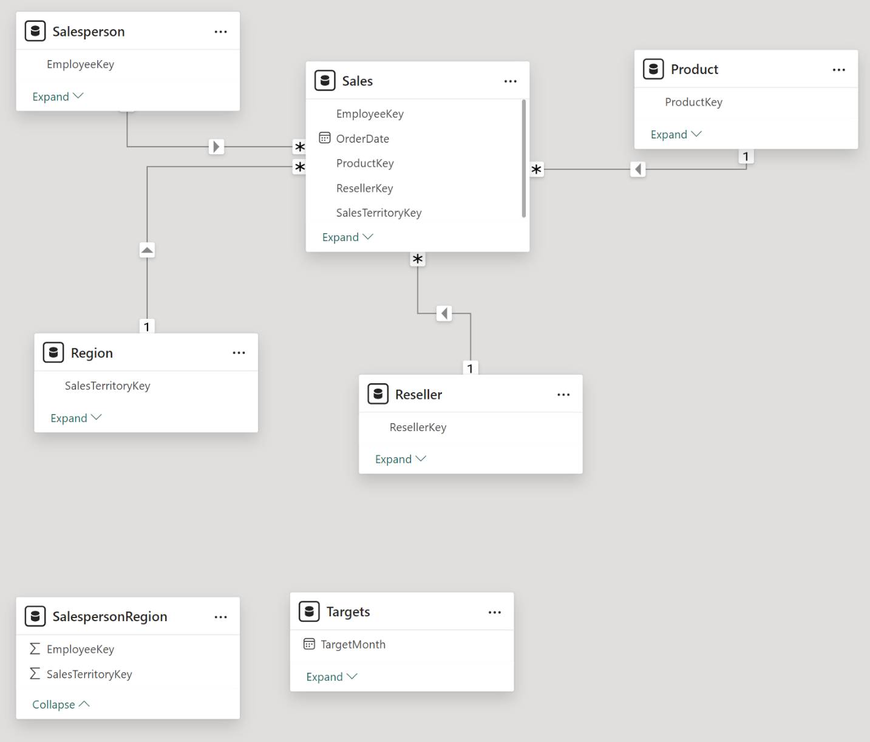
- In the report view, notice that the table visual updated to display different values for each product category.
Filters applied to the Product table now propagate to the Sales table.
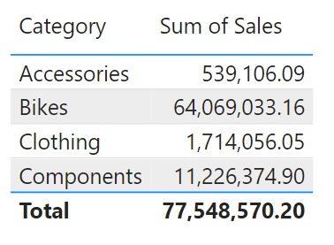
- Save the Power BI Desktop file.

Configure the Product table
In this task, you’ll configure the Product table with a hierarchy and display folder.
- In Model view > Data pane, if necessary, expand the Product table to reveal all fields.
- To create a hierarchy, in the Data pane, right-click the Category column, and then select Create Hierarchy.
- Update the name to Products (right-click or double-click to rename).
- To add the second level to the hierarchy, in the Properties pane, in the Hierarchy dropdown list, select Subcategory (you might need to scroll down inside the pane).
- To add the third level to the hierarchy, in the Hierarchy dropdown list, select Product.
- To complete the hierarchy design, select Apply Level Changes.
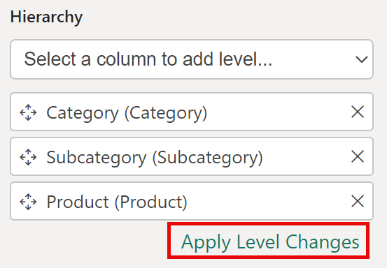
- In the Data pane, notice the Products hierarchy. To reveal the hierarchy levels, expand the Products hierarchy.
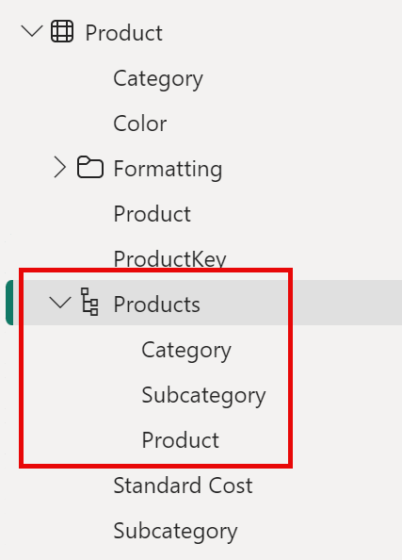
- To organize columns into a display folder, in the Data pane, first select the Background Color Format column.
- While pressing the Ctrl key, select the Font Color Format column.
- In the Properties pane, in the Display Folder box, enter Formatting.
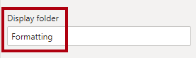
- In the Data pane, notice that the two columns are now inside a folder.
Display folders are a great way to organize tables, especially for tables that comprise many fields. They’re logical presentation only.
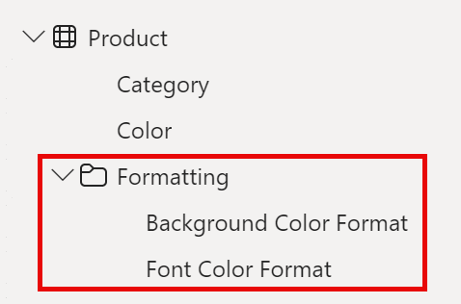

Configure the Region table
In this task, you’ll configure the Region table with a hierarchy and updated categories.
- In the Region table, create a hierarchy named Regions, with the following three levels:
  - Group
  - Country
  - Region
- Select the Country column (not the Country hierarchy level).
- In the Properties pane, expand the Advanced section (at the bottom of the pane), and then in the Data Category dropdown list, select Country/Region.
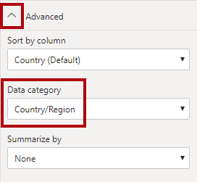
Data categorization can provide hints to the report designer. In this case, categorizing the column as country or region provides more accurate information to Power BI when it renders a map visualization.

Configure the Reseller table
In this task, you’ll configure the Reseller table to add a hierarchy and update data categories.
- In the Reseller table, create a hierarchy named Resellers, with the following two levels:
  - Business Type
  - Reseller
- Create a second hierarchy named Geography, with the following four levels:
  - Country-Region
  - State-Province
  - City
  - Reseller
- Set the Data Category for the following columns (not within the hierarchy):
  - Country-Region to Country/Region
  - State-Province to State or Province
  - City to City

Configure the Sales table
In this task, you’ll configure the Sales table with updated descriptions, formatting, and summarization.
- In the Sales table, select the Cost column.
- In the Properties pane, in the Description box, enter: Based on standard cost.
Descriptions can be applied to tables, columns, hierarchies, or measures. In the Data pane, description text is revealed in a tooltip when a report author hovers their cursor over the field.
- Select the Quantity column.
- In the Properties pane, from inside the Formatting section, slide the Thousands Separator property to Yes.
- Select the Unit Price column.
- In the Properties pane, from inside the Formatting section, set the Decimal Places property to 2.
- In the Advanced group (you may need to scroll down to locate it), in the Summarize By dropdown list, select Average.
By default, numeric columns will summarize by summing values together. This default behavior isn’t suitable for a column like Unit Price, which represents a rate. Setting the default summarization to average will produce a meaningful result.

Bulk update properties
In this task, you’ll update multiple columns using single bulk updates. You’ll use this approach to hide columns, and format column values.
- From the Model view > Data pane, select the Product | ProductKey column.
- While pressing the Ctrl key, select the following 13 columns (spanning multiple tables):
  - Region | SalesTerritoryKey
  - Reseller | ResellerKey
  - Sales | EmployeeKey
  - Sales | ProductKey
  - Sales | ResellerKey
  - Sales | SalesOrderNumber
  - Sales | SalesTerritoryKey
  - Salesperson | EmployeeID
  - Salesperson | EmployeeKey
  - Salesperson | UPN
  - SalespersonRegion | EmployeeKey
  - SalespersonRegion | SalesTerritoryKey
  - Targets | EmployeeID
- In the Properties pane, slide the Is Hidden property to Yes.
The columns were hidden because they’re either used by relationships or will be used in row-level security configuration or calculation logic.
You’ll use the SalesOrderNumber in a calculation in the Create DAX Calculations in Power BI Desktop lab.
- Multi-select the following three columns:
  - Product | Standard Cost
  - Sales | Cost
  - Sales | Sales
- In the Properties pane, from inside the Formatting section, set the Decimal Places property to 0 (zero).

Explore the model interface
In this task you’ll switch to Report view, review the data model interface, and configure the auto date/time setting.
- Switch to Report view.
- In the Data pane, notice the following:
  - Columns, hierarchies and their levels are fields, which can be used to configure report visuals
  - Only fields relevant to report authoring are visible
  - The SalespersonRegion table isn’t visible—because all of its fields are hidden
  - Spatial fields in the Region and Reseller table are adorned with a spatial icon
  - Fields adorned with the sigma symbol (Ʃ) will summarize, by default
  - A tooltip appears when hovering the cursor over the Sales | Cost field
- Expand the Sales | OrderDate field, and then notice that it reveals a Date Hierarchy. The Targets | TargetMonth field delivers a similar hierarchy.
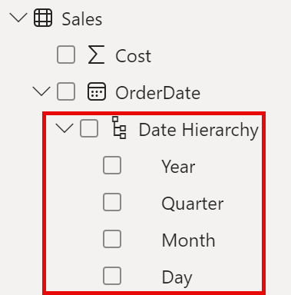
Important: These hierarchies weren’t created by you. They were created automatically as a default setting. There’s a problem, however. The Adventure Works financial year commences on July 1 of each year. But, in these automatically created date hierarchies, the date hierarchy year commences on January 1 of each year.
- To turn off the Auto date/time setting, Navigate to File > Options and Settings > Options.
- Under the Current File section, navigate to Data Load > Time Intelligence, and uncheck Auto Date/Time.
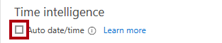
- In the Data pane, notice that the date hierarchies are no longer available.

Create quick measures
In this task, you’ll create two quick measures to calculate profit and profit margin. A quick measure creates the calculation formula for you. They’re easy and fast to create for simple and common calculations.
- In the Data pane, right-click the Sales table, and then select New Quick Measure.
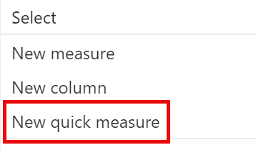
- In the Quick Measures window, in the Calculation dropdown list, from inside the Mathematical Operations group, select Subtraction.
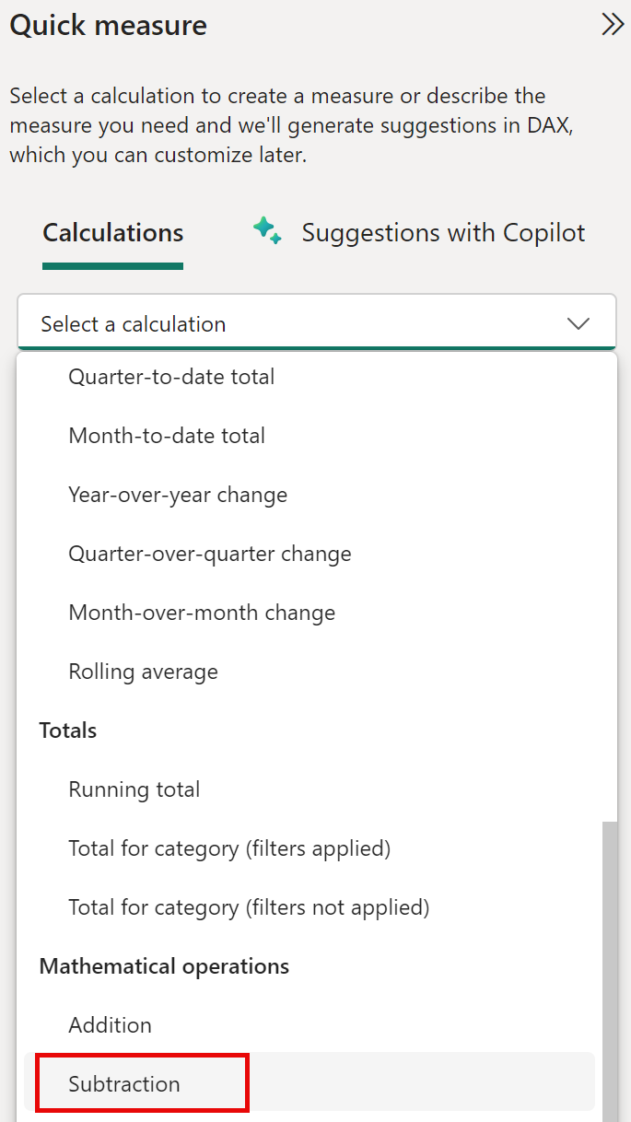
- In the Data pane of the Quick Measures window, expand the Sales table.
- Drag the Sales field into the Base Value box.
- Drag the Cost field into the Value to Subtract box, then select Add.
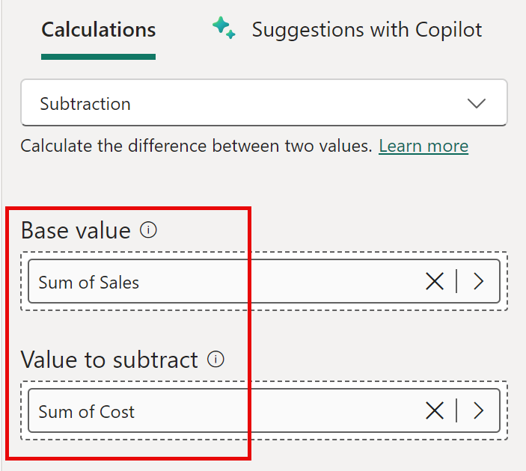
- In the Data pane, inside the Sales table, notice that new measure.
Measures are indicated by the calculator icon.
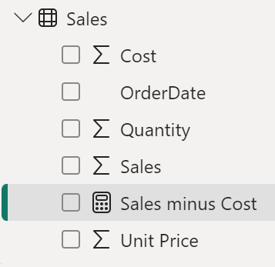
- To rename the measure, right-click it, select Rename, then rename to Profit.
Tip: To rename a field, you can also double-click it, or select it and press F2.
- In the Sales table, add a second quick measure, based on the following requirements:
  - Use the Division mathematical operation
  - Set the Numerator to the Sales | Profit field
  - Set the Denominator to Sales | Sales field
  - Rename the measure as Profit Margin
- Ensure the Profit Margin measure is selected, and then on the Measure Tools contextual ribbon, set the format to Percentage, with two decimal places.
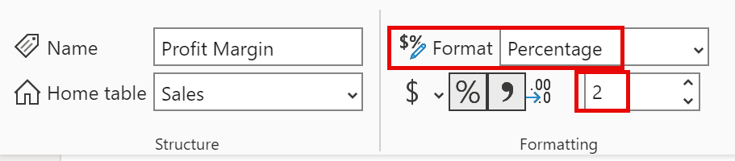
- To test the two measures, first select the Table visual.
- In the Data pane, check the two measures.
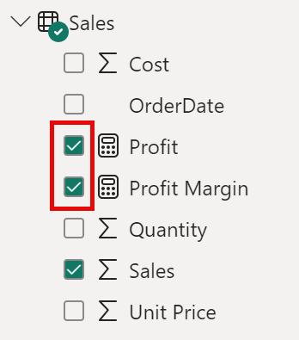
- Select and drag the right guide to widen the table visual.
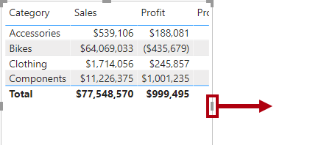
- Verify that the measures produce reasonable results that are correctly formatted.
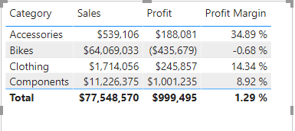

Create a many-to-many relationship
In this task, you’ll create a many-to-many relationship between the Salesperson table and the Sales table.
- In Power BI Desktop, in Report view, in the Data pane, check the follow two fields to create a new table visual.
  - Salesperson | Salesperson
  - Sales | Sales
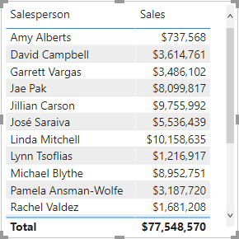
The table displays sales made by each salesperson. However, there’s another relationship between salespeople and sales. Some salespeople belong to one, two, or possibly more sales regions. In addition, sales regions can have multiple salespeople assigned to them.
From a performance management perspective, a salesperson’s sales (based on their assigned territories) need to be analyzed and compared with sales targets. You’ll create relationships to support this analysis in the next exercise.
- Notice that Michael Blythe has sold almost $9 million.
- Switch to Model view, then drag the SalespersonRegion table to position it between the Region and Salesperson tables.
- Use the drag-and-drop technique to create the following two model relationships:
  - Salesperson | EmployeeKey to SalespersonRegion | EmployeeKey
  - Region | SalesTerritoryKey to SalespersonRegion | SalesTerritoryKey
The SalespersonRegion table can be considered to be a bridging table.
- Switch to Report view, and then notice that the visual hasn’t updated—the sales result for Michael Blythe hasn’t changed.
- Switch back to Model view, and then follow the relationship filter directions (arrowhead) from the Salesperson table.
Consider that the Salesperson table filters the Sales table. It also filters the SalespersonRegion table, but it doesn’t continue by propagating filters to the Region table (the arrowhead is pointing the wrong direction).
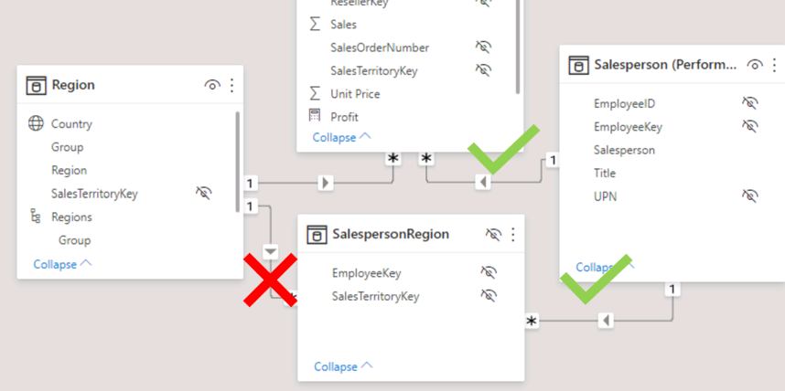
- To edit the relationship between the Region and SalespersonRegion tables, double-click the relationship.
- In the Edit Relationship window, in the Cross Filter Direction dropdown list, select Both.
- Check the Apply Security Filter in Both Directions checkbox, then select OK.
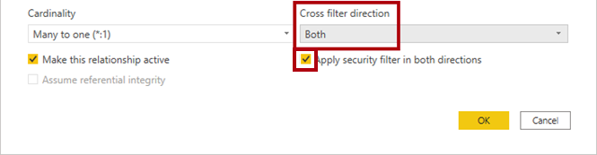
- Notice that the relationship has a double arrowhead now.
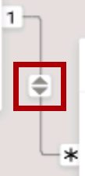
- Switch to Report view, and then notice that the sales values have still not changed.
The issue now relates to the fact that there are two possible filter propagation paths between the Salesperson and Sales tables. This ambiguity is internally resolved, based on a “least number of tables” assessment. To be clear, you shouldn’t design models with this type of ambiguity—the issue will be addressed in part later in this lab, and by the completion of the Create DAX Calculations in Power BI Desktop lab.
- Switch to Model view to force filter propagation via the bridging table. Edit (double-click) the relationship between the Salesperson and Sales tables.
- In the Edit Relationship window, uncheck the Make This Relationship Active checkbox, and select OK.
The filter propagation will now follow the only active path.
- In the diagram, notice that the inactive relationship is represented by a dashed line.
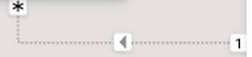
- Switch to Report view, and then notice that the sales for Michael Blythe are now nearly $22 million.
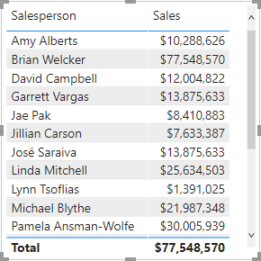
- Notice also, that the sales for each salesperson—if added—would exceed the table total.
It’s a common observation of a many-to-many relationship due to the double, triple, etc. counting of regional sales results. Consider Brian Welcker, the second salesperson listed. His sales amount equals the total sales amount. It’s the correct result due to the fact the he’s the Director of Sales; his sales are measured by the sales of all regions.
While the many-to-many relationship is now working, it’s now not possible to analyze sales made by a salesperson (because the relationship is inactive). You’ll be able to reactivate the relationship when you introduce a calculated table that will allow analyzing sales made in the sales region(s) assigned to the salesperson (for performance analysis) in the Create DAX Calculations in Power BI Desktop lab.
- Switch to Model view, and then in the diagram, select the Salesperson table.
- In the Properties pane, in the Name box, replace the text with Salesperson (Performance).
The renamed table now reflects its purpose: it’s used to report and analyze the performance of salespeople based on the sales of their assigned sales regions.

Relate the Targets table
In this task, you’ll create a relationship to the Targets table.
- Create a relationship from the Salesperson (Performance) | EmployeeID column and the Targets | EmployeeID column.
- In Report view, add the Targets | Target field to the table visual.
- Resize the table visual so all columns are visible.
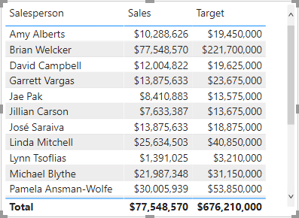
It’s now possible to visualize sales and targets—but take care for two reasons. First, there’s no filter on a time period, and so targets also include future target amounts. Second, targets aren’t additive, and so the total shouldn’t be displayed. They can either be disabled by formatting the visual or removed by using calculation logic.
Lab complete

Knowledge check

Summary
You have learned about modeling data in Power BI, which includes such topics as creating common date tables, learning about and configuring many-to-many relationships, resolving circular relationships, designing star schemas, and much more. These skills are crucial to the Power BI practitioner's toolkit so that it is easier to build visuals and hand off your report elements to other teams. With this foundation, you now have the ability to explore the many nuances of the semantic model.

Write DAX formulas for Power BI Desktop models

Introduction
By using Data Analysis Expressions (DAX), you can add three types of calculations to your semantic model:
- Calculated tables
- Calculated columns
- Measures
Note
DAX can also be used to define row-level security (RLS) rules, which are expressions that enforce filters over model tables. However, rules aren't considered to be model calculations so they're out of scope for this module. For more information, see Row-level security (RLS) with Power BI.

Calculated tables
You can write a DAX formula to add a calculated table to your model. The formula can duplicate or transform existing model data, or create a series of data, to produce a new table. Calculated table data is always imported into your model, so it increases the model storage size and can prolong data refresh time.
Note
A calculated table can't connect to external data; you need to use Power Query to accomplish that task.
Calculated tables can be useful in various scenarios:
- Date tables
- Role-playing dimensions
- What-if analysis

Date tables
Date tables are required to apply special time filters known as time intelligence. DAX time intelligence functions only work correctly when a date table is set up. When your source data doesn't include a date table, you can create one as calculated tables by using the CALENDAR or CALENDARAUTO DAX functions.

Role-playing dimensions
When two model tables have multiple relationships, it could be because your model has a role-playing dimension. For example, if you have a table named Sales that includes two date columns, OrderDateKey and ShipDateKey, both columns are related to the Date column in the Date table. In this case, the Date table is described as a role-playing dimension because it could play the role of order date or ship date.
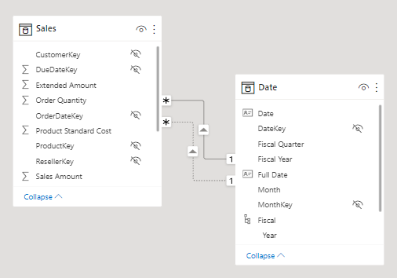
Microsoft Power BI models only allow one active relationship between tables, which in the model diagram is indicated as a solid line. The active relationship is used by default to propagate filters, which in this case would be from the Date table to the OrderDateKey column in the Sales table. Any remaining relationships between the two tables are inactive. In a model diagram, the relationships are represented as dashed lines. Inactive relationships are only used when they're expressly requested in a calculated formula by using the USERELATIONSHIP DAX function.
Perhaps a better model design could have two date tables, each with an active relationship to the Sales table. Thus, report users can filter by order date or ship date, or both at the same time. A calculated table can duplicate the Date table data to create the Ship Date table.
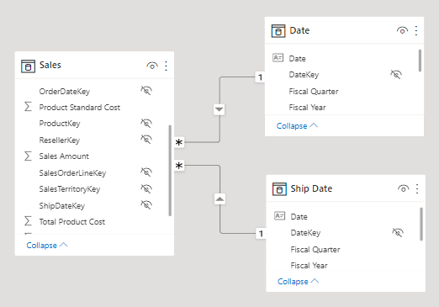

What-if analysis
Power BI Desktop supports a feature called What-if parameters. When you create a what-if parameter, a calculated table is automatically added to your model.
What-if parameters allow report users to select or filter by values that are stored in the calculated table. Measure formulas can use selected value(s) in a meaningful way. For example, a what-if parameter could allow the report user to select a hypothetical currency exchange rate, and a measure could divide revenue values (in a local currency) by the selected rate.
Notably, what-if calculated tables aren't related to other model tables because they're not used to propagate filters. For this reason, they're sometimes called disconnected tables.

Calculated columns
You can write a DAX formula to add a calculated column to any table in your model. The formula is evaluated for each table row and it returns a single value. When added to an Import storage mode table, the formula is evaluated when the semantic model is refreshed, and it increases the storage size of your model. When added to a DirectQuery storage mode table, the formula is evaluated by the underlying source database when the table is queried.
In the Fields pane, calculated columns are enhanced with a special icon. The following example shows a single calculated column in the Customer table called Age.
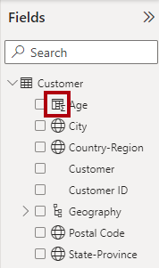

Measures
You can write a DAX formula to add a measure to any table in your model. The formula is concerned with achieving summarization over model data. Similar to a calculated column, the formula must return a single value. Unlike calculated columns, which are evaluated at data refresh time, measures are evaluated at query time. Their results are never stored in the model.
In the Fields pane, measures are shown with the calculator icon. The following example shows three measures in the Sales table: Cost, Profit, and Revenue.
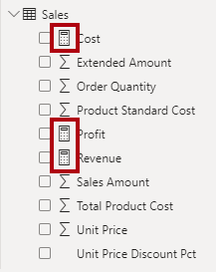
Occasionally, measures can be described as explicit measures. To be clear, explicit measures are model calculations that are written in DAX and are commonly referred to as simply measures. Yet, the concept of implicit measures exists, too. Implicit measures are columns that can be summarized by visuals in simplistic ways, like count, sum, minimum, maximum, and so on. You can identify implicit measures in the Fields pane because they're shown with the sigma symbol ( ∑ ).
Note
Any column can be summarized when added to a visual. Therefore, whether they're shown with the sigma symbol or not, when they're added to a visual, they can be set up as implicit measures.
Additionally, no such concept as a calculated measure exists in tabular modeling. The word calculated is used to describe calculated tables and calculated columns, which distinguishes them from tables and columns that originate from Power Query. Power Query doesn't have the concept of an explicit measure.

Write DAX formulas
Each model calculation type, calculated table, calculated column, or measure is defined by its name, followed by the equals symbol (=), which is then followed by a DAX formula. Use the following template to create a model calculation:
DAX
<Calculation name> = <DAX formula>
For example, the definition of the Ship Date calculated table that duplicates the Date table data is:
DAX
Ship Date = 'Date'
A DAX formula consists of expressions that return a result. The result is either a table object or a scalar value. Calculated table formulas must return a table object; calculated column and measure formulas must return a scalar value (single value).
Formulas are assembled by using:
- DAX functions
- DAX operators
- References to model objects
- Constant values, like the number 24 or the literal text "FY" (abbreviation for fiscal year)
- DAX variables
- Whitespace
Tip
When entering DAX formulas in Power BI Desktop, you have the benefit of IntelliSense. IntelliSense is a code-completion aid that lists functions and model resources. When you select a DAX function, it also provides you with a definition and description. We recommend that you use IntelliSense to help you quickly build accurate formulas.

DAX functions
Similar to Microsoft Excel, DAX is a functional language meaning that formulas rely on functions to accomplish specific goals. Typically, DAX functions have arguments that allow passing in variables. Formulas can use many function calls and will often nest functions within other functions.
In a formula, function names must be followed by parentheses. Within the parentheses, variables are passed in.
Note
Some functions don't take arguments, or arguments might be optional.
Working with DAX functions is described later in this module.

DAX operators
Formulas also rely on operators, which can perform arithmetic calculations, compare values, work with strings, or test conditions.
DAX operators are described in more detail later in this module.

References to model objects
Formulas can only refer to three types of model objects: tables, columns, or measures. A formula can't refer to a hierarchy or a hierarchy level. (Recall that a hierarchy level is based on a column, so your formula can refer to a hierarchy level's column.)

Table references
When you reference a table in a formula, officially, the table name is enclosed within single quotation marks. In the following calculated table definition, notice that the Date table is enclosed within single quotation marks.
DAX
Ship Date = 'Date'
However, single quotation marks can be omitted when both of the following conditions are true:
- The table name does not include embedded spaces.
- The table name isn't a reserved word that's used by DAX. All DAX function names and operators are reserved words. Date is a DAX function name, which explains why, when you are referencing a table named Date, that you must enclose it within single quotation marks.
In the following calculated table definition, it's possible to omit the single quotation marks when referencing the Airport table:
DAX
Arrival Airport = Airport

Column references
When you reference a column in a formula, the column name must be enclosed within square brackets. Optionally, it can be preceded by its table name. For example, the following measure definition refers to the Sales Amount column.
DAX
Revenue = SUM([Sales Amount])
Because column names are unique within a table but not necessarily unique within the model, you can disambiguate the column reference by preceding it with its table name. This disambiguated column is known as a fully qualified column. Some DAX functions require passing in fully qualified columns.
Tip
To improve the readability of your formulas, we recommend that you always precede a column reference with its table name.
The previous example measure definition can be rewritten as:
DAX
Revenue = SUM(Sales[Sales Amount])

Measure references
When you reference a measure in a formula, like column name references, the measure name must be enclosed within square brackets. For example, the following measure definition refers to the Revenue and Cost measures.
DAX
Profit = [Revenue] - [Cost]
If you're a DAX beginner, the fact that column and measure references are always enclosed within square brackets can cause confusion when you're trying to read a formula. However, as you become proficient with DAX fundamentals, you'll be able to determine which type of object it is because, in DAX formulas, columns, and measures are used in different ways.
Tip
It's possible to precede a measure reference with its table name. However, measures are a model-level object. While they're assigned to a home table, it's only a cosmetic relationship to logically organize measures in the Fields pane.
Therefore, while we recommend that you always precede a column reference with its table name, the inverse is true for measures: We recommend that you never precede a measure reference with its table name.
For more information, see Column and measure references.

DAX variables
Formulas can declare DAX variables to store results.
How and when to use DAX variables is described later in this module.

Whitespace
Whitespace refers to characters that you can use to format your formulas in a way that's quick and simple to understand. Whitespace characters include:
- Spaces
- Tabs
- Carriage returns
Whitespace is optional and it doesn't modify your formula logic or negatively impact performance. We strongly recommend that you adopt a format style and apply it consistently, and consider the following recommendations:
- Use spaces between operators.
- Use tabs to indent nested function calls.
- Use carriage returns to separate function arguments, especially when it's too long to fit on a single line. Formatting in this way makes it simpler to troubleshoot, especially when the formula is missing a parenthesis.
- Err on the side of too much whitespace than too little.
Tip
In the formula bar, to enter a carriage return, press Shift+Enter. Pressing Enter alone will commit your formula.
Consider the following measure definition that's written in a single line and that includes five DAX function calls:
DAX
Revenue YoY % = DIVIDE([Revenue] - CALCULATE([Revenue], SAMEPERIODLASTYEAR('Date'[Date])), CALCULATE([Revenue], SAMEPERIODLASTYEAR('Date'[Date])))
The following example is the same measure definition but now formatted, which helps make it easier to read and understand:
DAX
Revenue YoY % =
DIVIDE(
[Revenue]
- CALCULATE(
[Revenue],
SAMEPERIODLASTYEAR('Date'[Date])
),
CALCULATE(
[Revenue],
SAMEPERIODLASTYEAR('Date'[Date])
)
)
Try formatting the measure on your own. Open the Adventure Works DW 2020 M02.pbix Power BI Desktop file and then, in the Fields pane, expand the Sales table and then select the Revenue YoY % measure. In the formula bar, use tab and carriage return characters to produce the same result as the previous example. When you add a carriage return, remember to press Shift+Enter.
This measure definition can be further improved for readability and performance, which will be explained later in this module.
Tip
An excellent formatting tool from another source that can help you format your calculations is DAX Formatter. This tool allows you to paste in your calculation and format it. You can then copy the formatted calculation to the clipboard and paste it back into Power BI Desktop.

DAX data types
Semantic model columns have a set data type, which ensures that all column values conform to that data type. Column data types are defined in Power Query, or in the case of calculated columns, it's inferred from the formula. Measure data types, similar to calculated column data types, are inferred from the formula.
Model data types aren't the same as DAX data types, though a direct relationship exists between them. The following table lists the model data types and DAX data types. Notice the supported range of values for each data type.
Model data type | DAX data type | Description
Whole number | 64-bit integer | -2⁶³ through 2⁶³-1
Decimal number | 64-bit real | Negative: -1.79 x 10³⁰⁸ through -2.23 x 10⁻³⁰⁸ - zero (0) - positive: 2.23 x 10⁻³⁰⁸ through 1.79 x 10³⁰⁸ - Limited to 17 decimal digits
Boolean | Boolean | TRUE or FALSE
Text | String | Unicode character string
Date | Date/time | Valid dates are all dates after January 1, 1900
Currency | Currency | -9.22 x 10¹⁴ through 9.22 x 10¹⁴ - limited to four decimal digits of fixed precision
N/A | BLANK | In some cases, it's the equivalent of a database (SQL) NULL

BLANK data type
The BLANK data type deserves a special mention. DAX uses BLANK for both database NULL and for blank cells in Excel. BLANK doesn't mean zero. Perhaps it might be simpler to think of it as the absence of a value.
Two DAX functions are related to the BLANK data type: the BLANK DAX function returns BLANK, while the ISBLANK DAX function tests whether an expression evaluates to BLANK.

Work with DAX functions
The DAX function library consists of hundreds of functions, each designed to accomplish a specific goal.
Because DAX originated with the Power Pivot add-in for Microsoft Excel 2010, over 80 functions are available that can also be found in Excel. It was a deliberate design strategy by Microsoft to ensure that Excel users can quickly become productive with DAX.
However, many functions exist that you won't find in Excel because they're specific to data modeling:
- Relationship navigation functions
- Filter context modification functions
- Iterator functions
- Time intelligence functions
- Path functions
Tip
To search for documentation that is related to a DAX function, in a web search, enter the keyword DAX followed by the function name.
For more information, see the DAX function reference.

Functions that originate from Excel
The following sections consider several useful functions that you might already be familiar with because they exist in Excel.
The IF DAX function tests whether a condition that's provided as the first argument is met. It returns one value if the condition is TRUE and returns the other value if the condition is FALSE. The function's syntax is:
DAX
IF(<logical_test>, <value_if_true>[, <value_if_false>])
Tip
A function argument is optional when documentation shows it enclosed within square brackets.
If logical_test evaluates to FALSE and value_if_false isn't provided, the function will return BLANK.
Many Excel summarization functions are available, including SUM, COUNT, AVERAGE, MIN, MAX, and many others. The only difference is that in DAX, you pass in a column reference, whereas in Excel, you pass in a range of cells.
Many Excel mathematic, text, date and time, information, and logical functions are available as well. For example, a small sample of Excel functions that are available in DAX include ABS, ROUND, SQRT, LEN, LEFT, RIGHT, UPPER, DATE, YEAR, MONTH, NOW, ISNUMBER, TRUE, FALSE, AND, OR, NOT, and IFERROR.

Functions that don't originate from Excel
Two useful DAX functions that aren't specific to modeling and that don't originate from Excel are DISTINCTCOUNT and DIVIDE.

DISTINCTCOUNT function
You can use the DISTINCTCOUNT DAX function to count the number of distinct values in a column. This function is especially powerful in an analytics solution. Consider that the count of customers is different from the count of distinct customers. The latter doesn't count repeat customers, so the difference is "How many customers" compared with "How many different customers."

DIVIDE function
You can use the DIVIDE DAX function to achieve division. You must pass in numerator and denominator expressions. Optionally, you can pass in a value that represents an alternate result. The DIVIDE function's syntax is:
DAX
DIVIDE(<numerator>, <denominator>[, <alternate_result>])
The DIVIDE function automatically handles division by zero cases. If an alternate result isn't passed in, and the denominator is zero or BLANK, the function returns BLANK. When an alternate result is passed in, it's returned instead of BLANK.
This function is convenient because it saves your expression from having to first test the denominator value. The function is also better optimized for testing the denominator value than the IF function. The performance gain is significant because checking for division by zero is expensive. What's more, using the DIVIDE function results in a more concise and elegant expression.
Tip
We recommend that you use the DIVIDE function whenever the denominator is an expression that could return zero or BLANK. In the case that the denominator is a constant value, we recommend that you use the divide operator (/), which is introduced later in this module. In this case, the division is guaranteed to succeed, and your expression will perform better because it will avoid unnecessary testing.

Use DAX operators
Your DAX formulas can use operators to create expressions that perform arithmetic calculations, compare values, work with strings, or test conditions.
Tip
Many DAX operators and precedence order are the same as those found in Excel.

Arithmetic operators
The following table lists the arithmetic operators.
Operator | Description
+ | Addition
- | Subtraction
* | Multiplication
/ | Division
^ | Exponentiation
Remember, when you are dividing two expressions, and when the denominator could return zero or BLANK, it's more efficient and safer to use the DIVIDE DAX function.

Comparison operators
The following table lists the comparison operators, which are used to compare two values. The result is either TRUE or FALSE.
Operator | Description
= | Equal to
== | Strict equal to
> | Greater than
< | Less than
>= | Greater than or equal to
<= | Less than or equal to
<> | Not equal to
All comparison operators, except strict equal to (==), treat BLANK as equal to the number zero, an empty string (""), the date December 30, 1899, or FALSE. It means that the expression [Revenue] = 0 will be TRUE when the value of [Revenue] is either zero or BLANK. In contrast, [Revenue] == 0 is TRUE only when the value of [Revenue] is zero.

Text concatenation operator
Use the ampersand (&) character to connect, or concatenate, two text values to produce one continuous text value. For example, consider the following calculated column definition:
DAX
Model Color = 'Product'[Model] & "-" & 'Product'[Color]

Logical operators
Use logical operators to combine expressions that produce a single result. The following
Operator | Description
&& | Creates an AND condition between two expressions where each has a Boolean result. If both expressions return TRUE, the combination of the expressions also returns TRUE; otherwise the combination returns FALSE.
|| (double pipe) | Creates an OR condition between two logical expressions. If either expression returns TRUE, the result is TRUE; only when both expressions are FALSE is the result FALSE.
IN | Creates a logical OR condition between each row that is being compared to a table. Note: The table constructor syntax uses braces.
NOT | Inverts the state of a Boolean expression (FALSE to TRUE, and vice versa).
An example that uses the IN logical operator is the ANZ Revenue measure definition, which uses the CALCULATE DAX function to enforce a specific filter of two countries/regions: Australia and New Zealand.
Note
You'll be introduced to the powerful CALCULATE function when you learn how to modify the filter context.
DAX
ANZ Revenue =
CALCULATE(
[Revenue],
Customer[Country-Region] IN {
"Australia",
"New Zealand"
}
)

Operator precedence
When your DAX formula includes multiple operators, DAX uses rules to determine the evaluation order, which is known as an operator precedence. Operations are ordered according to the following table.
Operator | Description
^ | Exponentiation
- | Sign (as in -1)
* and / | Multiplication and division
NOT | NOT
+ and - | Addition and subtraction
& | Concatenation of two strings of text
=,==,<,>,<=,>=,<> | Comparison
When the operators have equal precedence value, they're ordered from left to right.
In general, operator precedence is the same as what's found in Excel. If you need to override the evaluation order, then group operations within parentheses.
For example, consider the following calculated column definition:
DAX
Extended Amount = Sales[Order Quantity] * Sales[Unit Price] * 1 - [Unit Price Discount Pct]
This sample calculated column definition produces an incorrect result because multiplication happens before the subtraction. The following correct calculated column definition uses parentheses to ensure that the subtractions happen before the multiplications.
DAX
Extended Amount = Sales[Order Quantity] * Sales[Unit Price] * (1 - [Unit Price Discount Pct])
Tip
Remembering operator precedence rules can be challenging, especially for DAX beginners. Consequently, we recommend that you test your formulas thoroughly. When the formulas don't produce the correct result due to an incorrect evaluation order, you can experiment by adding parentheses to adjust the evaluation order. You can also add parentheses to improve the readability of your formulas.
For more information about DAX operators and precedence order, see DAX operators.

Implicit conversion
When writing a DAX formula that uses operators to combine different data types, you don't need to explicitly convert types. Usually, DAX automatically identifies the data types of referenced model objects and performs implicit conversions where necessary to complete the specified operation.
However, some limitations might exist on the values that can be successfully converted. If a value or a column has a data type that's incompatible with the current operation, DAX returns an error. For example, the attempt to multiply a date value will create an error because it isn't logical.
BLANK is handled differently, depending on the operator that is used. It's handled similar to how Excel treats BLANK, but differently to how databases (SQL) treat NULL. BLANK is treated as zero when acted on by arithmetic operators and as an empty string when concatenated to a string.
Tip
Remembering how BLANK is handled can be challenging, especially for DAX beginners. Consequently, we recommend that you test your formulas thoroughly. When BLANKs create unexpected results, consider using the IF and ISBLANK DAX functions to test for BLANK, and then respond in an appropriate way.

Use DAX variables
You can declare DAX variables in your formula expressions. When you declare at least one variable, a RETURN clause is used to define the expression, which then refers to the variables.
We recommend that you use variables because they offer several benefits:
- Improving the readability and maintenance of your formulas.
- Improving performance because variables are evaluated once and only when or if they're needed.
- Allowing (at design time) straightforward testing of a complex formula by returning the variable of interest.
The following example shows a formula that declares a variable. The Revenue YoY % measure definition is rewritten to declare a variable that's assigned the value of the prior year's revenue.
DAX
Revenue YoY % =
VAR RevenuePriorYear =
CALCULATE(
[Revenue],
SAMEPERIODLASTYEAR('Date'[Date])
)
RETURN
DIVIDE(
[Revenue] - RevenuePriorYear,
RevenuePriorYear
)
Notice that the RETURN clause refers to the variable twice. This improved measure definition formula will run in at least half the time because it doesn't need to evaluate the prior year's revenue twice.
In the Adventure Works DW 2020 M02.pbix Power BI Desktop file, refactor the Revenue YoY % measure to produce the same result as the previous example.
For more information on using DAX variables, see Use variables to improve your formulas.

Knowledge check

Summary
In this module, you learned how DAX can be used to enhance your model with calculations. Calculation types include calculated tables, calculated columns, and measures.
You also learned about DAX fundamentals, which are essential for writing accurate and efficient DAX formulas. The fundamentals covered how to write DAX formulas, and you were introduced to important topics about DAX data types, DAX functions, DAX operators, references to model objects, constants, and using DAX variables.

Add measures to Power BI Desktop models

Introduction
Measures in Microsoft Power BI models are either implicit or explicit. Implicit measures are automatic behaviors that allow visuals to summarize model column data. Explicit measures, also known simply as measures, are calculations that you can add to your model. This module focuses on how you can use implicit measures.
In the Fields pane, a column that's shown with the sigma symbol ( ∑ ) indicates two facts:
- It's a numeric column.
- It will summarize column values when it is used in a visual (when added to a field well that supports summarization).
In the following image, notice that the Sales table includes only fields that can be summarized, including the Profit Amount calculated column.
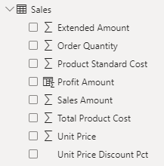
As a data modeler, you can control if and how the column summarizes by setting the Summarization property to Don't summarize or to a specific aggregation function. When you set the Summarization property to Don't summarize, the sigma symbol will no longer show next to the column in the Fields pane.
To observe how report authors can use implicit measures, you can first download and open the Adventure Works DW 2020 M04.pbix file.
In the report, from the Sales table, add the Sales Amount field to the matrix visual that groups fiscal year and month on its rows.
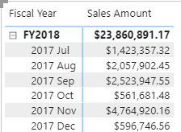
To determine how the column is summarized, in the visual fields pane, for the Sales Amount field, select the arrow and then review the context menu options.
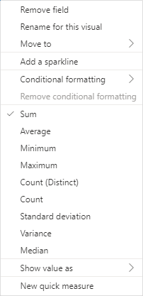
Notice that the Sum aggregation function has a check mark next to it. This check mark indicates that the column is summarized by summing column values together. It's also possible to change the aggregation function by selecting any of the other options like average, minimum, and so on.
Next, add the Unit Price field to the matrix visual.
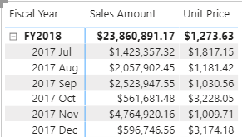
The default summarization is now set to Average (the modeler knows that it's inappropriate to sum unit price values together because they're rates, which are non-additive).
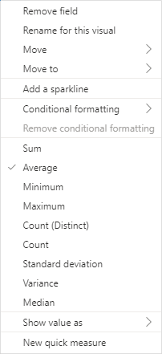
Implicit measures allow the report author to start with a default summarization technique and lets them modify it to suit their visual requirements.
Numeric columns support the greatest range of aggregation functions:
- Sum
- Average
- Minimum
- Maximum
- Count (Distinct)
- Count
- Standard deviation
- Variance
- Median

Summarize non-numeric columns
Non-numeric columns can be summarized. However, the sigma symbol does not show next to non-numeric columns in the Fields pane because they don't summarize by default.
Text columns allow the following aggregations:
- First (alphabetically)
- Last (alphabetically)
- Count (Distinct)
- Count
Date columns allow the following aggregations:
- Earliest
- Latest
- Count (Distinct)
- Count
Boolean columns allow the following aggregations:
- Count (Distinct)
- Count

Benefits of implicit measures
Several benefits are associated with implicit measures. Implicit measures are simple concepts to learn and use, and they provide flexibility in the way that report authors visualize model data. Additionally, they mean less work for you as a data modeler because you don't have to create explicit calculations.

Limitations of implicit measures
Implicit measures do have limitations. Despite setting an appropriate summarization method, report authors could choose to aggregate a column in unsuitable ways. For example, in the matrix visual, you could modify the aggregate function of Unit Price to Sum.
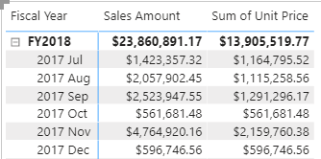
The report visual obeys your setup, but it has now produced a Sum of Unit Price column, which presents misleading data.
The most significant limitation of implicit measures is that they only work for simple scenarios, meaning that they can only summarize column values that use a specific aggregation function. Therefore, in situations when you need to calculate the ratio of each month's sales amount over the yearly sales amount, you'll need to produce an explicit measure by writing a Data Analysis Expressions (DAX) formula to achieve that more sophisticated requirement.
Implicit measures don't work when the model is queried by using Multidimensional Expressions (MDX). This language expects explicit measures and can't summarize column data. It's used when a Power BI semantic model is queried by using Analyze in Excel or when a Power BI paginated report uses a query that is generated by the MDX graphical query designer.

Create simple measures
You can write a DAX formula to add a measure to any table in your model. A measure formula must return a scalar or single value.
Note
In tabular modeling, no such concept as a calculated measure exists. The word calculated is used to describe calculated tables and calculated columns. It distinguishes them from tables and columns that originate from Power Query, which doesn't have the concept of an explicit measure.
Measures don't store values in the model. Instead, they're used at query time to return summarizations of model data. Additionally, measures can't reference a table or column directly; they must pass the table or column into a function to produce a summarization.
A simple measure is one that aggregates the values of a single column; it does what implicit measures do automatically.
In the next example, you will add a measure to the Sales table. In the Fields pane, select the Sales table. To create a measure, in the Table Tools contextual ribbon, from inside the Calculations group, select New measure.
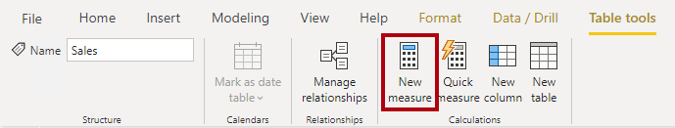
In the formula bar, enter the following measure definition and then press Enter.
DAX
Revenue =
SUM(Sales[Sales Amount])
The measure definition adds the Revenue measure to the Sales table. It uses the SUM DAX function to sum the values of the Sales Amount column.
On the Measure tools contextual ribbon, inside the Formatting group, set the decimal places to 2.
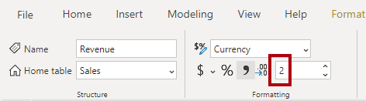
Tip
Immediately after you create a measure, set the formatting options to ensure well-presented and consistent values in all report visuals.
Now, add the Revenue measure to the matrix visual. Notice that it produces the same result as the Sales Amount implicit measure.
In the matrix visual, remove Sales Amount and Sum of Unit Price.
Next, you will create more measures. Create the Cost measure by using the following measure definition, and then set the format with two decimal places.
DAX
Cost =
SUM(Sales[Total Product Cost])
Create the Profit measure, and then set the format with two decimal places.
DAX
Profit =
SUM(Sales[Profit Amount])
Notice that the Profit Amount column is a calculated column. This topic will be discussed later in this module.
Next, create the Quantity measure and format it as a whole number with the thousands separator.
DAX
Quantity =
SUM(Sales[Order Quantity])
Create three unit price measures and then set the format of each with two decimal places. Notice the different DAX aggregation functions that are used: MIN, MAX, and AVERAGE.
DAX
Minimum Price =
MIN(Sales[Unit Price])
DAX
Maximum Price =
MAX(Sales[Unit Price])
DAX
Average Price =
AVERAGE(Sales[Unit Price])
Now, hide the Unit Price column, which results in report authors losing their ability to summarize the column except by using your measures.
Tip
Adding measures and hiding columns is how you, the data modeler, can limit summarization options.
Next, create the following two measures, which count the number of orders and order lines. Format both measures with zero decimal places.
DAX
Order Line Count =
COUNT(Sales[SalesOrderLineKey])
DAX
Order Count =
DISTINCTCOUNT('Sales Order'[Sales Order])
The COUNT DAX function counts the number of non-BLANK values in a column, while the DISTINCTCOUNT DAX function counts the number of distinct values in a column. Because an order can have one or more order lines, the Sales Order column will have duplicate values. A distinct count of values in this column will correctly count the number of orders.
Alternatively, you can choose the better way to write the Order Line Count measure. Instead of counting values in a column, it's semantically clearer to use the COUNTROWS DAX function. Unlike the previously introduced aggregation functions, which aggregate column values, the COUNTROWS function counts the number of rows for a table.
Modify the Order Line Count measure formula you created above to the following parameters:
DAX
Order Line Count =
COUNTROWS(Sales)
Add each of the measures to the matrix visual.
All measures that you've created are considered simple measures because they aggregate a single column or single table.

Create compound measures
When a measure references one or more measures, it's known as a compound measure.
For this example, you will modify the Profit measure by using the following measure definition. Format the measure with two decimal places.
DAX
Profit =
[Revenue] - [Cost]
Next, add the Profit measure to the matrix visual.
Now that your model provides a way to summarize profit, you can delete the Profit Amount calculated column.
By removing this calculated column, you've optimized the semantic model. Removing this columns results in a decreased semantic model size and shorter data refresh times. The Profit Amount calculated column wasn't required because the Profit measure can directly produce the required result.

Create quick measures
Microsoft Power BI Desktop includes a feature named Quick Measures. This feature helps you to quickly perform common, powerful calculations by generating the DAX expression for you.
Many categories of calculations and ways to modify each calculation are available to fit your needs. Moreover, you are able to see the DAX that's generated by the quick measure and use it to jumpstart or expand your DAX knowledge.
In this next example, you'll create another compound measure to calculate profit margin. However, this time, you'll create it as a quick measure.
In the Fields pane, select the Sales table. On the Table tools contextual ribbon, from inside the Calculations group, select Quick measure.
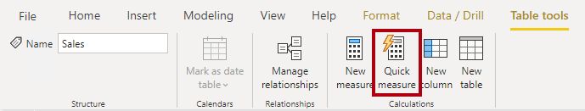
In the Quick measures window, in the Calculation drop-down list, locate the Mathematical operations group (you might need to scroll down the list) and then select Division.
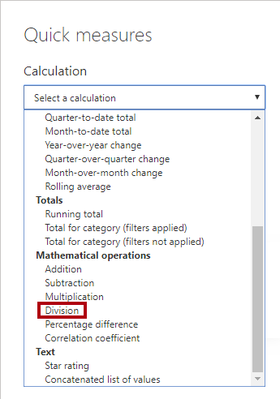
From the Fields list (in the Quick measures window), expand the Sales table and then drag the Profit measure into the Numerator box. Then, drag the Revenue measure into the Denominator box.
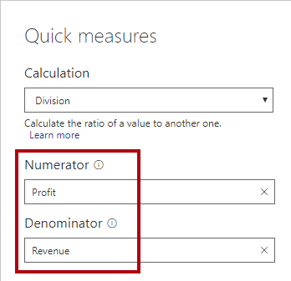
Select Add. In the Fields pane, notice the addition of the new compound measure. In the formula bar, review the measure definition.
DAX
Profit divided by Revenue =
DIVIDE([Profit], [Revenue])
Note
After the quick measure has been created, you must apply any changes in the formula bar.
Rename the measure as Profit Margin, and then set the format to a percentage with two decimal places.
Add the Profit Margin measure to the matrix visual.

Compare calculated columns with measures
DAX beginners often experience a degree of confusion about calculated columns and measures. The following section reviews the similarities and differences between both.
Regarding similarities between calculated columns and measures, both are:
- Calculations that you can add to your semantic model.
- Defined by using a DAX formula.
- Referenced in DAX formulas by enclosing their names within square brackets.
The areas where calculated columns and measures differ include:
- Purpose - Calculated columns extend a table with a new column, while measures define how to summarize model data.
- Evaluation - Calculated columns are evaluated by using row context at data refresh time, while measures are evaluated by using filter context at query time. Filter context is introduced in a later module; it's an important topic to understand and master so that you can achieve complex summarizations.
- Storage - Calculated columns (in Import storage mode tables) store a value for each row in the table, but a measure never stores values in the model.
- Visual use - Calculated columns (like any column) can be used to filter, group, or summarize (as an implicit measure), whereas measures are designed to summarize.

Knowledge check

Exercise - Create DAX Calculations in Power BI Desktop

Lab story
In this lab you’ll create calculated tables, calculated columns, and simple measures using Data Analysis Expressions (DAX).
In this lab you learn how to:
- Create calculated tables
- Create calculated columns
- Create measures
This lab should take approximately 45 minutes.

Get started
To complete this exercise, first open a web browser and enter the following URL to download the zip folder:
https://github.com/MicrosoftLearning/PL-300-Microsoft-Power-BI-Data-Analyst/raw/Main/Allfiles/Labs/04-create-dax-calculations-in-power-bi-desktop\04-intro-dax.zip
Extract the folder to the C:\Users\Student\Downloads\04-intro-dax folder.
Open the 04-Starter-Sales Analysis.pbix file.
Note: You can dismiss the sign-in by selecting Cancel. Close any other informational windows. Select Apply Later, if prompted to apply changes.

Create the Salesperson calculated table
In this task, you’ll create the Salesperson calculated table (direct relationship to Sales).
A calculated table is created by first entering the table name, followed by the equals symbol (=), followed by a DAX formula that returns a table. The table name can’t already exist in the data model.
The formula bar supports entering a valid DAX formula. It includes features like auto-complete, Intellisense and color-coding, enabling you to quickly and accurately enter the formula.
- In Power BI Desktop, in Report view, on the Modeling ribbon, from inside the Calculations group, select New Table.
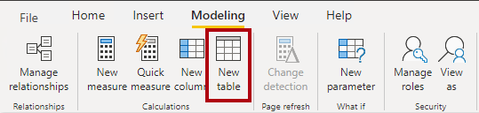
- In the formula bar (which opens directly beneath the ribbon when creating or editing calculations), type Salesperson =, press Shift+Enter, type ‘Salesperson (Performance)’, and then press Enter.
Note:
For your convenience, all DAX definitions in this lab can be copied from the snippets file, located in 04-intro-dax\Snippets.txt.
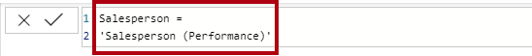
This table definition creates a copy of the Salesperson (Performance) table. It copies the data only, however model properties like visibility, formatting, etc. aren’t copied.
- In the Data pane, notice that the table icon has an additional calculator in front of it (denoting a calculated table).
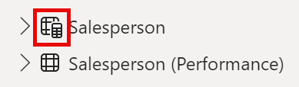
Note:
Calculated tables are defined by using a DAX formula that returns a table. It’s important to understand that calculated tables increase the size of the data model because they materialize and store values. They’re recomputed whenever formula dependencies are refreshed, as will be the case for this data model when new (future) date values are loaded into tables.
Unlike Power Query-sourced tables, calculated tables can’t be used to load data from external data sources. They can only transform data based on what has already been loaded into the data model.
- Switch to Model view, and notice that the Salesperson table is available (you may need to reset view to find table).
- Create a relationship from the Salesperson | EmployeeKey column to the Sales | EmployeeKey column.
- Right-click the inactive relationship between the Salesperson (Performance) and Sales tables, and then select Delete. When prompted to confirm the deletion, select Yes.
- In the Salesperson table, multi-select the following columns, and then hide them (set the Is Hidden property to Yes):
  - EmployeeID
  - EmployeeKey
  - UPN
- In the model diagram, select the Salesperson table.
- In the Properties pane, in the Description box, enter: Salesperson related to Sales
You may recall that descriptions appear as tooltips in the Data pane when the user hovers their cursor over a table or field.
- For the Salesperson (Performance) table, set the description to: Salesperson related to region(s)
The data model now provides two alternatives when analyzing salespeople. The Salesperson table allows analyzing sales made by a salesperson, while the Salesperson (Performance) table allows analyzing sales made in the sales region(s) assigned to the salesperson.

Create the Date table
In this task, you’ll create the Date table.
- Switch to Table view. On the Home ribbon tab, from inside the Calculations group, select New Table.
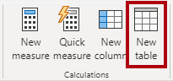
- In the formula bar, enter the following DAX:
code
Date =
CALENDARAUTO(6)
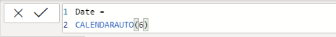
The CALENDARAUTO() function returns a single-column table consisting of date values. The “auto” behavior scans all data model date columns to determine the earliest and latest date values stored in the data model. It then creates one row for each date within this range, extending the range in either direction to ensure full years of data is stored.
This function can take a single optional argument that is the last month number of a year. When omitted, the value is 12, meaning that December is the last month of the year. In this case, 6 is entered, meaning that June is the last month of the year.
- Notice the column of date values which are formatted using US regional settings (that is, mm/dd/yyyy).
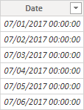
- At the bottom-left corner, in the status bar, notice the table statistics, confirming that 1826 rows of data have been generated, which represents five full years’ data.

Create calculated columns
In this task, you’ll add more columns to enable filtering and grouping by different time periods. You’ll also create a calculated column to control the sort order of other columns.
Note:
For your convenience, all DAX definitions in this lab can be copied from the Snippets.txt file.
- On the Table Tools contextual ribbon, from inside the Calculations group, select New Column.
A calculated column is created by first entering the column name, followed by the equals symbol (=), followed by a DAX formula that returns a single-value result. The column name can’t already exist in the table.
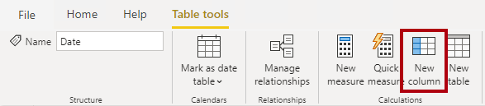
- In the formula bar, type the following (or copy from the snippets file), and then press Enter:
The formula uses the date’s year value but adds one to the year value when the month is after June. It’s how fiscal years at Adventure Works are calculated.
code
Year =
"FY" & YEAR('Date'[Date]) + IF(MONTH('Date'[Date]) > 6, 1)
- Use the snippets file definitions to create the following two calculated columns for the Date table:
  - Quarter
  - Month
- Verify the new columns have been added.
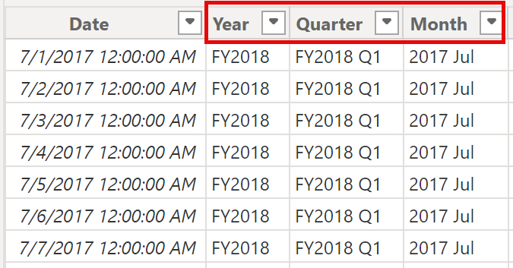
- To validate the calculations, switch to Report view.
- To create a new report page, select the plus icon next to Page 1.
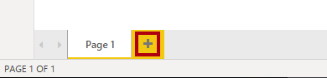
- To add a matrix visual to the new report page, in the Visualizations pane, select the matrix visual type.
Tip:
You can hover the cursor over each icon to reveal a tooltip describing the visual type.
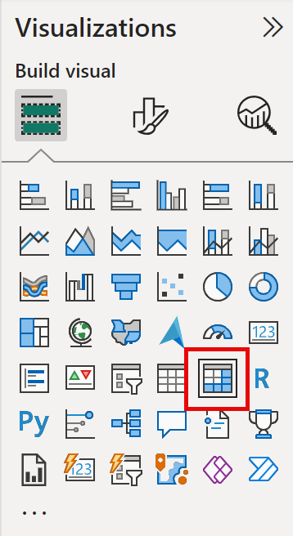
- In the Data pane, from inside the Date table, drag the Year field into the Rows well/area.
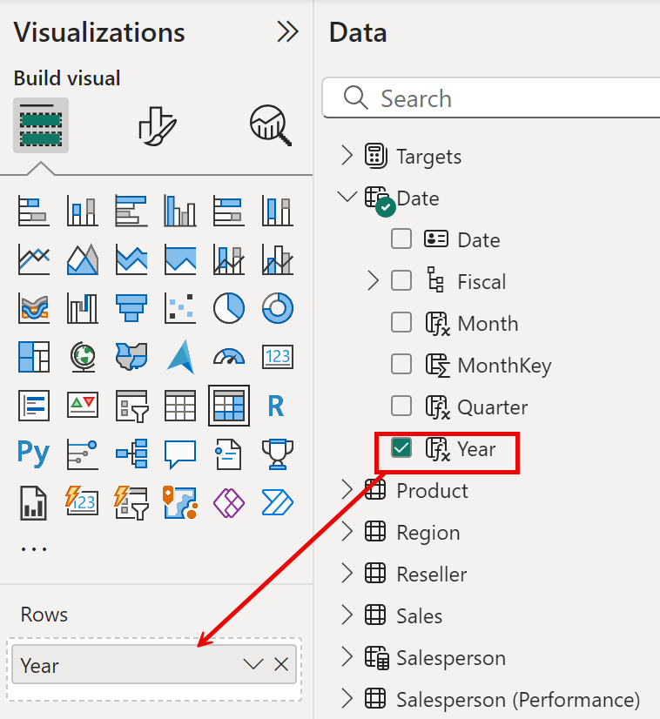
- Drag the Month field into the Rows well/area, directly beneath the Year field.
- At the top-right of the matrix visual (or bottom, depending on the location of the visual), select the forked-double arrow icon (which will expand all years down one level).
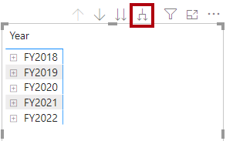
- Notice that the years expand to months, and that the months are sorted alphabetically rather than chronologically.
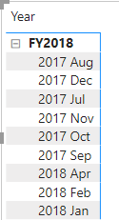
By default, text values sort alphabetically, numbers sort from smallest to largest, and dates sort from earliest to latest.
- To customize the Month field sort order, switch to Table view.
- Add the MonthKey column to the Date table.
code
MonthKey =
(YEAR('Date'[Date]) * 100) + MONTH('Date'[Date])
This formula computes a numeric value for each year/month combination.
- In Table view, verify that the new column contains numeric values (for example, 201707 for July 2017, etc.).
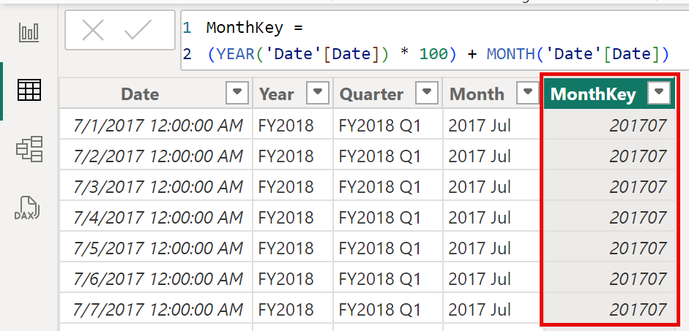
- Switch back to Report view. In the Data pane and select Month.
- On the Column Tools contextual ribbon, from inside the Sort group, select Sort by Column, and then select MonthKey.
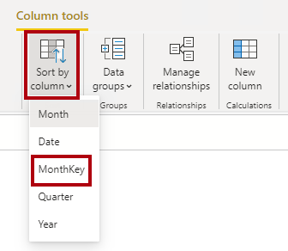
- In the matrix visual, notice that the months are now chronologically sorted.
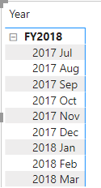

Complete the Date table
In this task, you’ll complete the design of the Date table by hiding a column and creating a hierarchy. You’ll then create relationships to the Sales and Targets tables.
- Switch to Model view. In the Date table, hide the MonthKey column (set Is Hidden to Yes).
- On the Data right side pane, select the Date table, right select on the Year column, and select create hierarchy.
- Rename newly created hierarchy to Fiscal by right select and Rename.
- Add the follow two remaining fields to the Fiscal hierarchy by selecting them in the Data pane, right clicking, selecting Add to hierarchy -> Fiscal.
  - Quarter
  - Month
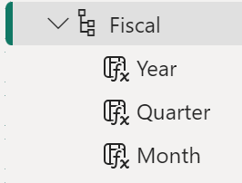
- Create the following two model relationships:
  - Date | Date to Sales | OrderDate
  - Date | Date to Targets | TargetMonth
The labs use a shorthand notation to reference a field. It will look like this: Sales | Unit Price. In this example, Sales is the table name and Unit Price is the field name.
- Hide the following two columns:
  - Sales | OrderDate
  - Targets | TargetMonth

Mark the Date table
In this task, you’ll mark the Date table as a date table.
- Switch to Report view. In the Data pane, select the Date table (not the Date field).
- On the Table Tools contextual ribbon, from inside the Calendars group, select Mark as Date Table.
- In the Mark as a Date Table window, slide the Mark as a Date Table property to Yes and in the Choose a date column dropdown list, select Date. Select Save.
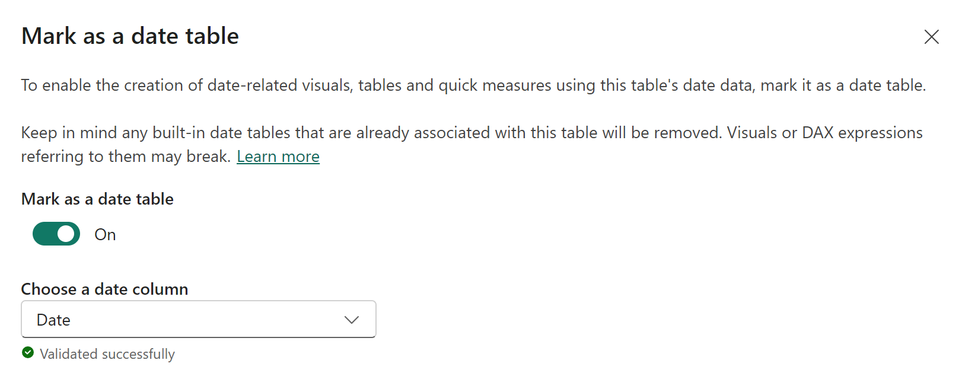
- Save the Power BI Desktop file.
Power BI Desktop now understands that this table defines date (time). This design approach for a date table is suitable when you don’t have a date table in your data source. If you have a data warehouse, it would be appropriate to load date data from its date dimension table rather than “redefining” date logic in your data model.

Create simple measures
In this task, you’ll create simple measures. Simple measures aggregate values in a single column or count rows of a table.
- In Report view, on Page 2, in the Data pane, drag the Sales | Unit Price field into the matrix visual.
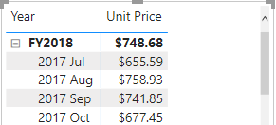
- In the visual fields pane (located beneath the Visualizations pane), in the Values field well/area, notice that Unit Price is listed as the Average of Unit Price. Select the down-arrow for Unit Price, and then notice the available menu options.
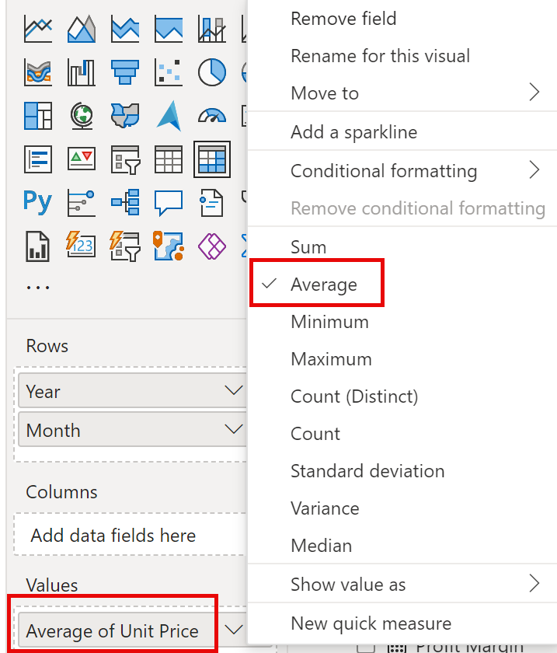
Visible numeric columns allow report authors at report design time to decide how column values will summarize (or not). It can result in inappropriate reporting. Some data modelers don’t like leaving things to chance, however, and choose to hide these columns and instead expose aggregation logic defined in measures. It’s the approach you’ll now take in this lab.
- To create a measure, in the Data pane, right-click the Sales table, and then select New Measure.
- In the formula bar, add the following measure definition:
code
Avg Price =
AVERAGE(Sales[Unit Price])
- Add the Avg Price measure to the matrix visual, and notice that it produces the same result as the Unit Price column (but with different formatting).
- In the Values well, open the context menu for the Avg Price field, and notice that it isn’t possible to change the aggregation technique.
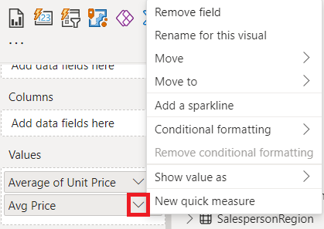
It’s not possible to modify the aggregation behavior of a measure.
- Use the snippets file definitions to create the following five measures for the Sales table:
  - Median Price
  - Min Price
  - Max Price
  - Orders
  - Order Lines
The DISTINCTCOUNT() function used in the Orders measure will count orders only once (ignoring duplicates). The COUNTROWS() function used in the Order Lines measure operates over a table.
In this case, the number of orders is calculated by counting the distinct SalesOrderNumber column values, while the number of order lines is simply the number of table rows (each row is a line of an order).
- Switch to Model view, and then multi-select the four price measures: Avg Price, Max Price, Median Price, and Min Price.
- For the multi-selection of measures, configure the following requirements:
  - Set the format to two decimal places
  - Assign to a display folder named Pricing
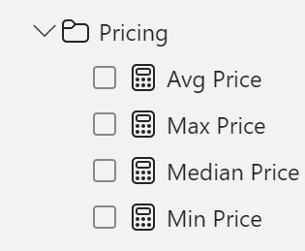
- Hide the Unit Price column.
The Unit Price column is now not available to report authors. They must use the pricing measures you’ve added to the model. This design approach ensures that report authors won’t inappropriately aggregate prices, for example, by summing them.
- Multi-select the Order Lines and Orders measures, and then configure the following requirements:
  - Set the format use the thousands separator
  - Assign to a display folder named Counts
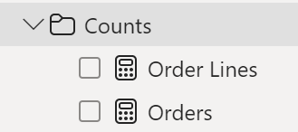
- In Report view, in the Values well/area of the matrix visual, for the Unit Price field, select X to remove it.
- Increase the size of the matrix visual to fill the page width and height.
- Add the following five measures to the matrix visual:
  - Median Price
  - Min Price
  - Max Price
  - Orders
  - Order Lines
- Verify that the results look sensible and are correctly formatted.
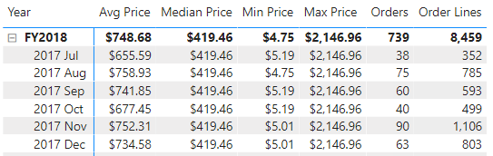

Create additional measures
In this task, you’ll create more measures that use more complex formulas.
- In Report view, select Page 1 and review the table visual, noticing the total for the Target column.
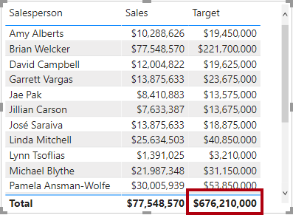
- Select the table visual, and then in the Visualizations pane, remove the Target field.
- Rename the Targets | Target column as Targets | TargetAmount.
Tip: There are several ways to rename the column in Report view: In the Data pane, you can right-click the column, and then select Rename—or, double-click the column, or press F2.
- Create the following measure on the Targets table:
code
Target =
IF(
HASONEVALUE('Salesperson (Performance)'[Salesperson]),
SUM(Targets[TargetAmount])
)
The HASONEVALUE() function tests whether a single value in the Salesperson column is filtered. When true, the expression returns the sum of target amounts (for just that salesperson). When false, BLANK is returned.
- Format the Target measure for zero decimal places.
Tip:
You can use the Measure Tools contextual ribbon.
- Hide the TargetAmount column.
Tip:
You can right-click the column in the Data pane, and then select Hide.
- Add the Target measure to the table visual.
- Notice that the Target column total is now BLANK.
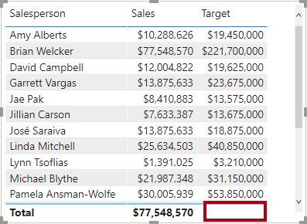
- Use the snippets file definitions to create the following two measures for the Targets table:
  - Variance
  - Variance Margin
- Format the Variance measure for zero decimal places.
- Format the Variance Margin measure as percentage with two decimal places.
- Add the Variance and Variance Margin measures to the table visual.
- Resize the table visual so all columns and rows can be seen.
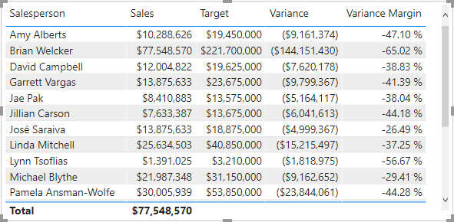
While it appears all salespeople aren’t meeting target, remember that the table visual isn’t yet filtered by a specific time period. You’ll produce sales performance reports that filter by a user-selected time period in the Design a Report in Power BI Desktop lab.
- At the top-right corner of the Data pane, collapse and then expand open the pane.
Collapsing and reopening the pane resets the content.
- Notice that the Targets table now appears at the top of the list.
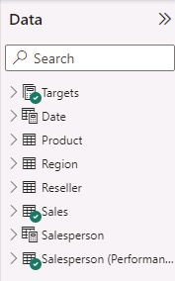
Tables that comprise only visible measures are automatically listed at the top of the list.
Lab complete

Summary
In this module, you learned that Power BI measures are either implicit or explicit. Implicit measures are automatic behaviors that are supported by visuals, while explicit measures use DAX formulas that summarize model data.
Explicit measures are important because they allow you to create complex DAX formulas to achieve the precise calculations that your report visuals need. While you learned to create simple and compound measures in this module, in later modules you'll learn to create more powerful measures by using filter modification functions and iterator functions.

Add calculated tables and columns to Power BI Desktop models

Introduction
You can write a Data Analysis Expressions (DAX) formula to add a calculated table to your model. The formula can duplicate or transform existing model data to produce a new table.
Note
A calculated table can't connect to external data; you must use Power Query to accomplish that task.
A calculated table formula must return a table object. The simplest formula can duplicate an existing model table.
Calculated tables have a cost: They increase the model storage size and they can prolong the data refresh time. The reason is because calculated tables recalculate when they have formula dependencies to refreshed tables.

Duplicate a table
The following section describes a common design challenge that can be solved by creating a calculated table. First, you should download and open the Adventure Works DW 2020 M03.pbix file and then switch to the model diagram.
In the model diagram, notice that the Sales table has three relationships to the Date table.
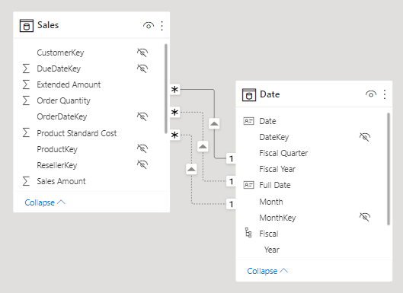
The model diagram shows three relationships because the Sales table stores sales data by order date, ship date, and due date. If you examine the OrderDateKey, ShipDateKey, and DueDateKey columns, notice that one relationship is represented by a solid line, which is the active relationship. The other relationships, which are represented by dashed lines, are inactive relationships.
Note
Only one active relationship can exist between any two model tables.
In the diagram, hover the cursor over the active relationship to highlight the related columns, which is how you would interact with the model diagram to learn about related columns. In this case, the active relationship filters the OrderDateKey column in the Sales table. Thus, filters that are applied to the Date table will propagate to the Sales table to filter by order date; they'll never filter by ship date or due date.
The next step is to delete the two inactive relationships between the Date table and the Sales table. To delete a relationship, right-click it and then select Delete in the context menu. Make sure that you delete both inactive relationships.
Next, add a new table to allow report users to filter sales by ship date. Switch to Report view and then, on the Modeling ribbon tab, from inside the Calculations group, select New table.
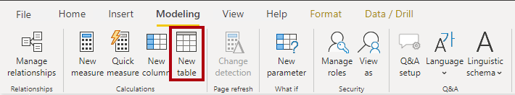
In the formula bar (located beneath the ribbon), enter the following calculated table definition and then press Enter.
DAX
Ship Date = 'Date'
The calculated table definition duplicates the Date table data to produce a new table named Ship Date. The Ship Date table has exactly the same columns and rows as the Date table. When the Date table data refreshes, the Ship Date table recalculates, so they'll always be in sync.
Switch to the model diagram, and then notice the addition of the Ship Date table.
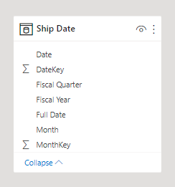
Next, create a relationship between the DateKey column in the Ship Date table and the ShipDateKey column in the Sales table. You can create the relationship by dragging the DateKey column in the Ship Date table onto the ShipDateKey column in the Sales table.
A calculated table only duplicates data; it doesn't duplicate any model properties or objects like column visibility or hierarchies. You'll need to set them up for the new table, if required.
Tip
It's possible to rename columns of a calculated table. In this example, it's a good idea to rename columns so that they better describe their purpose. For example, the Fiscal Year column in the Ship Date table can be renamed as Ship Fiscal Year. Accordingly, when fields from the Ship Date table are used in visuals, their names are automatically included in captions like the visual title or axis labels.
To complete the design of the Ship Date table, you can:
- Rename the following columns:
  - Date as Ship Date
  - Fiscal Year as Ship Fiscal Year
  - Fiscal Quarter as Ship Fiscal Quarter
  - Month as Ship Month
  - Full Date as Ship Full Date
- Sort the Ship Full Date column by the Ship Date column.
- Sort the Ship Month column by the MonthKey column.
- Hide the MonthKey column.
- Create a hierarchy named Fiscal with the following levels:
  - Ship Fiscal Year
  - Ship Fiscal Quarter
  - Ship Month
  - Ship Full Date
- Mark the Ship Date table as a date table by using the Ship Date column.
Calculated tables are useful to work in scenarios when multiple relationships between two tables exist, as previously described. They can also be used to add a date table to your model. Date tables are required to apply special time filters known as time intelligence.

Create a date table
In the next example, a second calculated table will be created, this time by using the CALENDARAUTO DAX function.
Create the Due Date calculated table by using the following definition.
DAX
Due Date = CALENDARAUTO(6)
The CALENDARAUTO DAX function takes a single optional argument, which is the last month number of the year, and returns a single-column table. If you don't pass in a month number, it's assumed to be 12 (for December). For example, at Adventure Works, their financial year ends on June 30 of each year, so the value 6 (for June) is passed in.
The function scans all date and date/time columns in your model to determine the earliest and latest stored date values. It then produces a complete set of dates that span all dates in your model, ensuring that full years of dates are loaded. For example, if the earliest date that is stored in your model is October 15, 2021, then the first date that is returned by the CALENDARAUTO function would be July 1, 2021. If the latest date that is stored in the model is June 15, 2022, then the last date that is returned by the CALENDARAUTO function would be June 30, 2022.
Effectively, the CALENDARAUTO function guarantees that the following requirements to mark a date table are met:
- The table must include a column of data type Date.
- The column must contain complete years.
- The column must not have missing dates.
Tip
You can also create a date table by using the CALENDAR DAX function and passing in two date values, which represent the date range. The function generates one row for each date within the range. You can pass in static date values or pass in expressions that retrieve the earliest/latest dates from specific columns in your model.
Next, switch to data view, and then in the Fields pane, select the Due Date table. Now, review the column of dates. You might want to order them to see the earliest date in the first row by selecting the arrow inside the Date column header and then sorting in ascending order.
Note
Ordering or filtering columns doesn't change how the values are stored. These functions help you explore and understand the data.
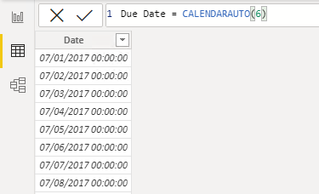
Now that the Date column is selected, review the message in the status bar (located in the lower-left corner). It describes how many rows that the table stores and how many distinct values are found in the selected column.
When the table rows and distinct values are the same, it means that the column contains unique values. That factor is important for two reasons: It satisfies the requirements to mark a date table, and it allows this column to be used in a model relationship as the one-side.
The Due Date calculated table will recalculate each time a table that contains a date column refreshes. In other words, when a row is loaded into the Sales table with an order date of July 1, 2022, the Due Date table will automatically extend to include dates through to the end of the next year: June 30, 2023.
The Due Date table requires additional columns to support the known filtering and grouping requirements, specifically by year, quarter, and month.

Create calculated columns
You can write a DAX formula to add a calculated column to any table in your model. A calculated column formula must return a scalar or single value.
Calculated columns in import models have a cost: They increase the model storage size and they can prolong the data refresh time. The reason is because calculated columns recalculate when they have formula dependencies to refreshed tables.
In data view, in the Fields pane, ensure that the Due Date table is selected. Before you create a calculated column, first rename the Date column to Due Date.
Now, you can add a calculated column to the Due Date table. To create a calculated column, in the Table tools contextual ribbon, from inside the Calculations group, select New column.
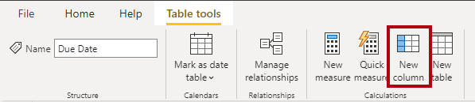
In the formula bar, enter the following calculated column definition and then press Enter.
DAX
Due Fiscal Year =
"FY"
& YEAR('Due Date'[Due Date])
+ IF(
MONTH('Due Date'[Due Date]) > 6,
1
)
The calculated column definition adds the Due Fiscal Year column to the Due Date table. The following steps describe how Microsoft Power BI evaluates the calculated column formula:
- The addition operator (+) is evaluated before the text concatenation operator (&).
- The YEAR DAX function returns the whole number value of the due date year.
- The IF DAX function returns the value when the due date month number is 7-12 (July to December); otherwise, it returns BLANK. (For example, because the Adventure Works financial year is July-June, the last six months of the calendar year will use the next calendar year as their financial year.)
- The year value is added to the value that is returned by the IF function, which is the value one or BLANK. If the value is BLANK, it's implicitly converted to zero (0) to allow the addition to produce the fiscal year value.
- The literal text value "FY" concatenated with the fiscal year value, which is implicitly converted to text.
Add a second calculated column by using the following definition:
DAX
Due Fiscal Quarter =
'Due Date'[Due Fiscal Year] & " Q"
& IF(
MONTH('Due Date'[Due Date]) <= 3,
3,
IF(
MONTH('Due Date'[Due Date]) <= 6,
4,
IF(
MONTH('Due Date'[Due Date]) <= 9,
1,
2
)
)
)
The calculated column definition adds the Due Fiscal Quarter column to the Due Date table. The IF function returns the quarter number (Quarter 1 is July-September), and the result is concatenated to the Due Fiscal Year column value and the literal text Q.
Add a third calculated column by using the following definition:
DAX
Due Month =
FORMAT('Due Date'[Due Date], "yyyy mmm")
The calculated column definition adds the Due Month column to the Due Date table. The FORMAT DAX function converts the Due Date column value to text by using a format string. In this case, the format string produces a label that describes the year and abbreviated month name.
Note
Many user-defined date/time formats exist. For more information, see Custom date and time formats for the FORMAT function.
Add a fourth calculated column by using the following definition:
DAX
Due Full Date =
FORMAT('Due Date'[Due Date], "yyyy mmm, dd")
Add a fifth calculated column by using the following definition:
DAX
MonthKey =
(YEAR('Due Date'[Due Date]) * 100) + MONTH('Due Date'[Due Date])
The MonthKey calculated column multiplies the due date year by the value 100 and then adds the month number of the due date. It produces a numeric value that can be used to sort the Due Month text values in chronological order.
Verify that the Due Date table has six columns. The first column was added when the calculated table was created, and the other five columns were added as calculated columns.
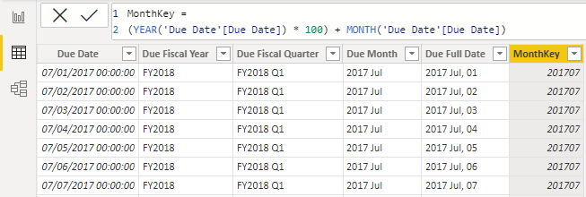
To complete the design of the Due Date table, you can:
- Sort the Due Full Date column by the Due Date column.
- Sort the Due Month column by the MonthKey column.
- Hide the MonthKey column.
- Create a hierarchy named Fiscal with the following levels:
  - Due Fiscal Year
  - Due Fiscal Quarter
  - Due Month
  - Due Full Date
- Mark the Due Date table as a date table by using the Due Date column.

Learn about row context
Now that you've created calculated columns, you can learn how their formulas are evaluated.
The formula for a calculated column is evaluated for each table row. Furthermore, it's evaluated within row context, which means the current row. Consider the Due Fiscal Year calculated column definition:
DAX
Due Fiscal Year =
"FY"
& YEAR('Due Date'[Due Date])
+ IF(
MONTH('Due Date'[Due Date]) <= 6,
1
)
When the formula is evaluated for each row, the 'Due Date'[Due Date] column reference returns the column value for that row. You might be familiar with this concept from working with formulas in Excel tables.
However, row context doesn't extend beyond the table. If your formula needs to reference columns in other tables, you have two options:
- If the tables are related, directly or indirectly, you can use the RELATED or RELATEDTABLE DAX function. The RELATED function retrieves the value at the one-side of the relationship, while the RELATEDTABLE retrieves values on the many-side. The RELATEDTABLE function returns a table object.
- When the tables aren't related, you can use the LOOKUPVALUE DAX function.
Generally, try to use the RELATED function whenever possible. It will usually perform better than the LOOKUPVALUE function due to the ways that relationship and column data is stored and indexed.
Now, add the following calculated column definition to the Sales table:
DAX
Discount Amount =
(
Sales[Order Quantity]
* RELATED('Product'[List Price])
) - Sales[Sales Amount]
The calculated column definition adds the Discount Amount column to the Sales table. Power BI evaluates the calculated column formula for each row of the Sales table. The values for the Order Quantity and Sales Amount columns are retrieved within row context. However, because the List Price column belongs to the Product table, the RELATED function is required to retrieve the list price value for the sale product.
Row context is used when calculated column formulas are evaluated. It's also used when a class of functions, known as iterator functions, are used. Iterator functions provide you with flexibility to create sophisticated summarizations. Iterator functions are described in a later module.

Choose a technique to add a column
There are three techniques that you can use to add columns to a model table:
- Add columns to a view or table (as a persisted column), and then source them in Power Query. This option only makes sense when your data source is a relational database and if you have the skills and permissions to do so. However, it's a good option because it supports ease of maintenance and allows reuse of the column logic in other models or reports.
- Add custom columns (using M) to Power Query queries.
- Add calculated columns (using DAX) to model tables.
Regardless of which technique you use, it results in the same outcome. Report users can't determine the origin of a column. Typically, they're not concerned with how the column was created but rather that it delivers the right data.
When multiple ways are available to add a column, you can consider using the approach that best fits your skills and that's supported by the language (M or DAX). However, the preference is to add custom columns in Power Query, whenever possible, because they load to the model in a more compact and optimal way.
When you need to add a column to a calculated table, make sure that you create a calculated column. Otherwise, we recommend that you only use a calculated column when the calculated column formula:
- Depends on summarized model data.
- Needs to use specialized modeling functions that are only available in DAX, such as the RELATED and RELATEDTABLE functions. Specialized functions can also include the DAX parent and child hierarchies, which are designed to naturalize a recursive relationship into columns, for example, in an employee table where each row stores a reference to the row of the manager (who is also an employee).

Knowledge check

Summary
In this module, you learned how to use DAX to extend your model designs with calculated tables and calculated columns. You also learned that calculated columns are evaluated within row context, and you learned how to correctly reference columns that belong to different tables. Finally, you learned that while many ways are available for adding new columns to your model, it's best to create Power Query custom columns whenever possible.

Modify DAX filter context in Power BI Desktop models

Introduction
Watch the following video to learn about filter context.
Filter context describes the filters that are applied during the evaluation of a measure or measure expression. Filters can be applied directly to columns, like a filter on the Fiscal Year column in the Date table for the value FY2020. Additionally, filters can be applied indirectly, which happens when model relationships propagate filters to other tables. For example, the Sales table receives a filter through its relationship with the Date table, filtering the Sales table rows to those with an OrderDateKey column value in FY2020.
Note
Calculated tables and calculated columns aren't evaluated within filter context. Calculated columns are evaluated in row context, though the formula can transition the row context to filter context, if it needs to summarize model data. Context transition is described in Unit 5.
At report design time, filters are applied in the Filters pane or to report visuals. The slicer visual is an example of a visual whose only purpose is to filter the report page (and other pages when it's configured as a synced slicer). Report visuals, which perform grouping, also apply filters. They're implied filters; the difference is that the filter result is visible in the visual. For example, a stacked column chart visual can filter by fiscal year FY2020, group by month, and summarize sales amount. The fiscal year filter isn't visible in the visual result, yet the grouping, which results in a column for each month, behaves as a filter.
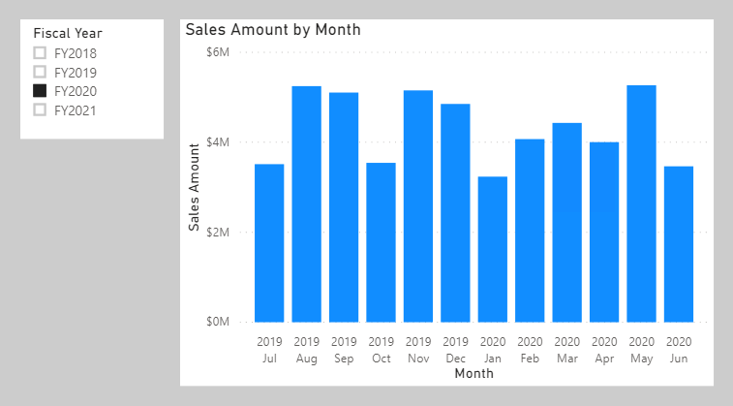
Not all filters are applied at report design time. Filters can be added when a report user interacts with the report. They can modify filter settings in the Filters pane, and they can cross-filter or cross-highlight visuals by selecting visual elements like columns, bars, or pie chart segments. These interactions apply additional filters to report page visuals (unless interactions have been disabled).
It's important to understand how filter context works. It guides you in defining the correct formula for your calculations. As you write more complex formulas, you'll identify times when you need to add, modify, or remove filters to achieve the desired result.
Consider an example that requires your formula to modify the filter context. Your objective is to produce a report visual that shows each sales region together with its revenue and revenue as a percentage of total revenue.
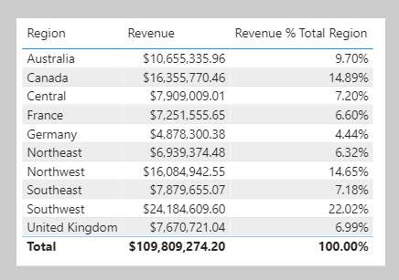
The Revenue % Total Region result is achieved by defining a measure expression that's the ratio of revenue divided by revenue for all regions. Therefore, for Australia, the ratio is 10,655,335.96 dollars divided by 109,809,274.20 dollars, which is 9.7 percent.
The numerator expression doesn't need to modify filter context; it should use the current filter context (a visual that groups by region applies a filter for that region). The denominator expression, however, needs to remove any region filters to achieve the result for all regions.
Tip
The key to writing complex measures is mastering these concepts:
- Understanding how filter context works.
- Understanding when and how to modify or remove filters to achieve a required result.
- Composing a formula to accurately and efficiently modify filter context.
Mastering these concepts takes practice and time. Rarely will students understand the concepts from the beginning of training. Therefore, be patient and persevere with the theory and activities. We recommend that you repeat this module at a later time to help reinforce key lessons.
The next unit introduces the CALCULATE DAX function. It's one of the most powerful DAX functions, allowing you to modify filter context when your formulas are evaluated.

Modify filter context
You can use the CALCULATE DAX function to modify filter context in your formulas. The syntax for the CALCULATE function is as follows:
DAX
CALCULATE(<expression>, [[<filter1>], <filter2>]…)
The function requires passing in an expression that returns a scalar value and as many filters as you need. The expression can be a measure (which is a named expression) or any expression that can be evaluated in filter context.
Filters can be Boolean expressions or table expressions. It's also possible to pass in filter modification functions that provide additional control when you're modifying filter context.
When you have multiple filters, they're evaluated by using the AND logical operator, which means that all conditions must be TRUE at the same time.
Note
The CALCULATETABLE DAX function performs exactly the same functionality as the CALCULATE function, except that it modifies the filter context that's applied to an expression that returns a table object. In this module, the explanations and examples use the CALCULATE function, but keep in mind that these scenarios could also apply to the CALCULATETABLE function.

Apply Boolean expression filters
A Boolean expression filter is an expression that evaluates to TRUE or FALSE. Boolean filters must abide by the following rules:
- They can reference only a single column.
- They cannot reference measures.
- They cannot use functions that scan or return a table that includes aggregation functions like SUM.
In this example, you will create a measure. First, download and open the Adventure Works DW 2020 M06.pbix file. Then add the following measure to the Sales table that filters the Revenue measure by using a Boolean expression filter for red products.
DAX
Revenue Red = CALCULATE([Revenue], 'Product'[Color] = "Red")
Add the Revenue Red measure to the table visual that is found on Page 1 of the report.
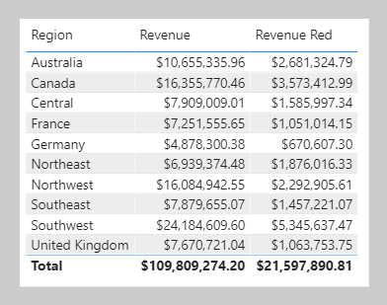
In this next example, the following measure filters the Revenue measure by multiple colors. Notice the use of the IN operator followed by a list of color values.
DAX
Revenue Red or Blue = CALCULATE([Revenue], 'Product'[Color] IN {"Red", "Blue"})
The following measure filters the Revenue measure by expensive products. Expensive products are those with a list price greater than USD 1000.
DAX
Revenue Expensive Products = CALCULATE([Revenue], 'Product'[List Price] > 1000)

Apply table expression filters
A table expression filter applies a table object as a filter. It could be a reference to a model table; however, it's likely a DAX function that returns a table object.
Commonly, you'll use the FILTER DAX function to apply complex filter conditions, including those that can't be defined by a Boolean filter expression. The FILTER function is classed as an iterator function, and so you would pass in a table, or table expression, and an expression to evaluate for each row of that table.
The FILTER function returns a table object with exactly the same structure as one that the table passed in. Its rows are a subset of those rows that were passed in, meaning the rows where the expression evaluated as TRUE.
The following example shows a table filter expression that uses the FILTER function:
DAX
Revenue High Margin Products =
CALCULATE(
[Revenue],
FILTER(
'Product',
'Product'[List Price] > 'Product'[Standard Cost] * 2
)
)
In this example, the FILTER function filters all rows of the Product table that are in filter context. Each row for a product where its list price exceeds double its standard cost is displayed as a row of the filtered table. Therefore, the Revenue measure is evaluated for all products that are returned by the FILTER function.
All filter expressions that are passed in to the CALCULATE function are table filter expressions. A Boolean filter expression is a shorthand notation to improve the writing and reading experience. Internally, Microsoft Power BI translates Boolean filter expressions to table filter expressions, which is how it translates your Revenue Red measure definition.
DAX
Revenue Red =
CALCULATE(
[Revenue],
FILTER(
'Product',
'Product'[Color] = "Red"
)
)

Filter behavior
Two possible standard outcomes occur when you add filter expressions to the CALCULATE function:
- If the columns (or tables) aren't in filter context, then new filters will be added to the filter context to evaluate the CALCULATE expression.
- If the columns (or tables) are already in filter context, the existing filters will be overwritten by the new filters to evaluate the CALCULATE expression.
The following examples show how adding filter expressions to the CALCULATE function works.
Note
In each of the examples, no filters are applied to the table visual.
As in the previous activity, the Revenue Red measure was added to a table visual that groups by region and displays revenue.

Because no filter is applied on the Color column in the Product table, the evaluation of the measure adds a new filter to filter context. In the first row, the value of $2,681,324.79 is for red products that were sold in the Australian region.
Switching the first column of the table visual from Region to Color will produce a different result because the Color column in the Product table is now in filter context.
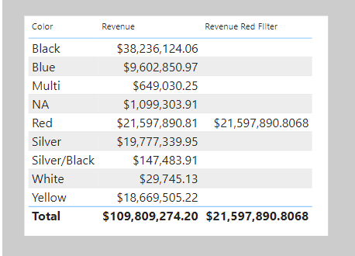
The Revenue Red measure formula evaluates the Revenue measure by adding a filter on the Color column (to red) in the Product table. Consequently, in this visual that groups by color, the measure formula overwrites the filter context with a new filter.
This result might or might not be what you want. The next unit introduces the KEEPFILTERS DAX function, which is a filter modification function that you can use to preserve filters rather than overwrite them.

Use filter modifier functions
When using the CALCULATE function, you can pass in filter modification functions, which allow you to accomplish more than adding filters alone.

Remove filters
Use the REMOVEFILTERS DAX function as a CALCULATE filter expression to remove filters from filter context. It can remove filters from one or more columns or from all columns of a single table.
Note
The REMOVEFILTERS function is relatively new. In previous versions of DAX, you removed filters by using the ALL DAX function or variants including the ALLEXCEPT and the ALLNOBLANKROW DAX functions. These functions behave as both filter modifiers and as functions that return table objects of distinct values. These functions are mentioned now because you're likely to find documentation and formula examples that remove filters by using them.
In the following example, you will add a new measure to the Sales table that evaluates the Revenue measure but does so by removing filters from the Sales Territory table. Format the measure as currency with two decimal places.
DAX
Revenue Total Region = CALCULATE([Revenue], REMOVEFILTERS('Sales Territory'))
Now, add the Revenue Total Region measure to the matrix visual that is found on Page 2 of the report. The matrix visual will group by three columns from the Sales Territory table on the rows: Group, Country, and Region.
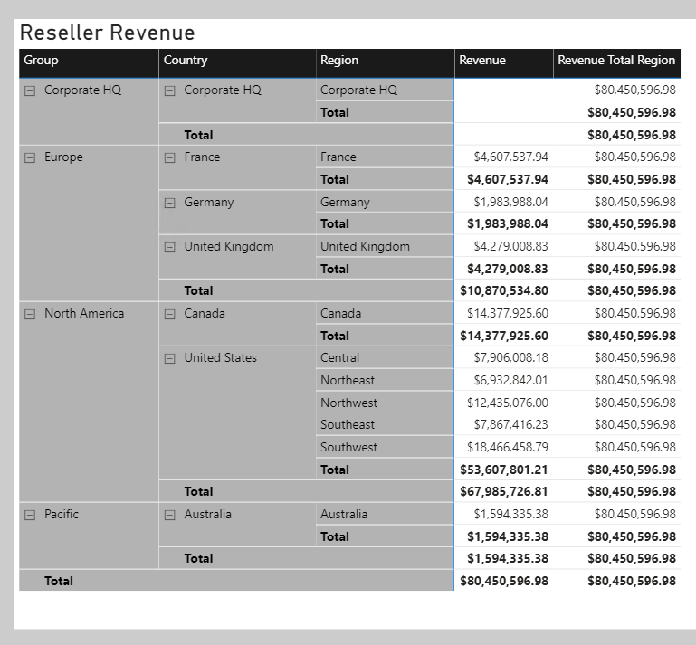
Notice that each Revenue Total Region value is the same. It's the value of total revenue.
While this result on its own isn't useful, when it's used as a denominator in a ratio, it calculates a percent of grand total. Therefore, you will now overwrite the Revenue Total Region measure definition with the following definition. (This new definition changes the measure name and declares two variables. Be sure to format the measure as a percentage with two decimal places.)
DAX
Revenue % Total Region =
VAR CurrentRegionRevenue = [Revenue]
VAR TotalRegionRevenue =
CALCULATE(
[Revenue],
REMOVEFILTERS('Sales Territory')
)
RETURN
DIVIDE(
CurrentRegionRevenue,
TotalRegionRevenue
)
Verify that the matrix visual now displays the Revenue % Total Region values.
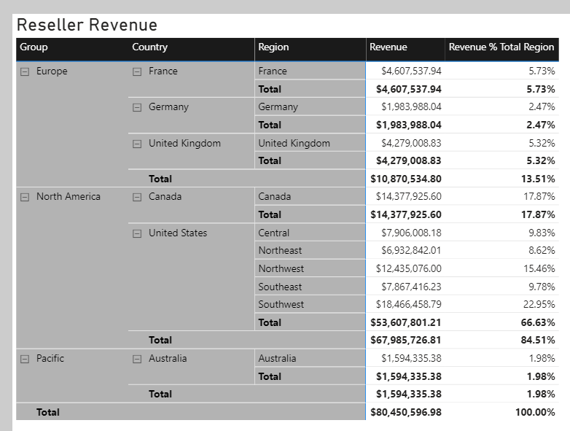
You'll now create another measure, but this time, you will calculate the ratio of revenue for a region divided by its country's or region's revenue.
Before you complete this task, notice that the Revenue % Total Region value for the Southwest region is 22.95 percent. Investigate the filter context for this cell. Switch to data view and then, in the Fields pane, select the Sales Territory table.
Apply the following column filters:
- Group - North America
- Country - United States
- Region - Southwest
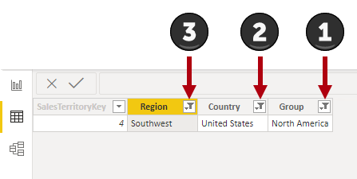
Notice that the filters reduce the table to only one row. Now, while thinking about your new objective to create a ratio of the region revenue over its country's revenue, clear the filter from the Region column.
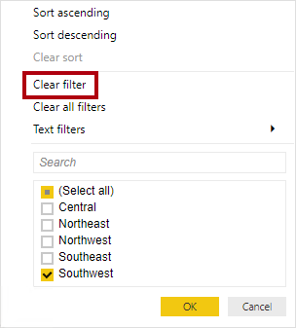
Notice that five rows now exist, each row belonging to the country United States. Accordingly, when you clear the Region column filters, while preserving filters on the Country and Group columns, you will have a new filter context that's for the region's country.
In the following measure definition, notice how you can clear or remove a filter from a column. In DAX logic, it's a small and subtle change that's made to the Revenue % Total Region measure formula: The REMOVEFILTERS function now removes filters from the Region column instead of all columns of the Sales Territory table.
DAX
Revenue % Total Country =
VAR CurrentRegionRevenue = [Revenue]
VAR TotalCountryRevenue =
CALCULATE(
[Revenue],
REMOVEFILTERS('Sales Territory'[Region])
)
RETURN
DIVIDE(
CurrentRegionRevenue,
TotalCountryRevenue
)
Add the Revenue % Total Country measure to the Sales table and then format it as a percentage with two decimal places. Add the new measure to the matrix visual.
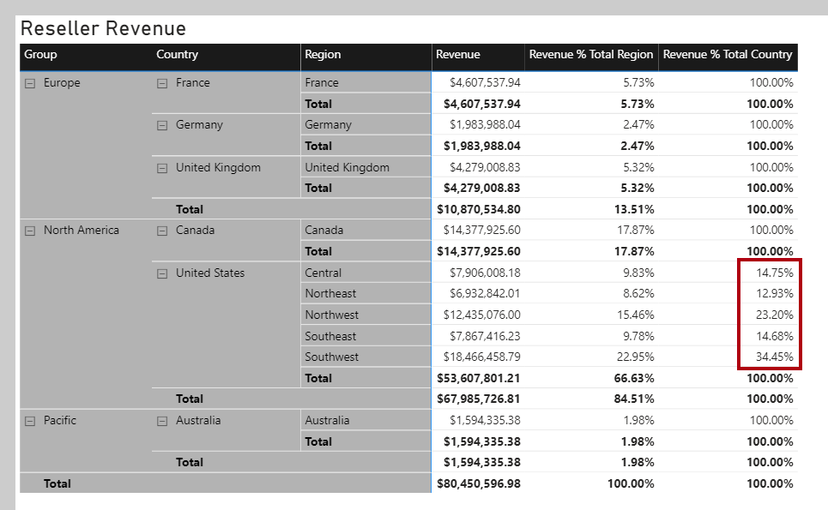
Notice that all values, except those values for United States regions, are 100 percent. The reason is because, at the Adventure Works company, the United States has regions, while all other countries/regions do not.
Note
Tabular models don't support ragged hierarchies, which are hierarchies with variable depths. Therefore, it's a common design approach to repeat parent (or other ancestor) values at lower levels of the hierarchy. For example, Australia doesn't have a region, so the country/region value is repeated as the region name. It's always better to store a meaningful value instead of BLANK.
The next example is last measure that you will create. Add the Revenue % Total Group measure, and then format it as a percentage with two decimal places. Then, add the new measure to the matrix visual.
DAX
Revenue % Total Group =
VAR CurrentRegionRevenue = [Revenue]
VAR TotalGroupRevenue =
CALCULATE(
[Revenue],
REMOVEFILTERS(
'Sales Territory'[Region],
'Sales Territory'[Country]
)
)
RETURN
DIVIDE(
CurrentRegionRevenue,
TotalGroupRevenue
)
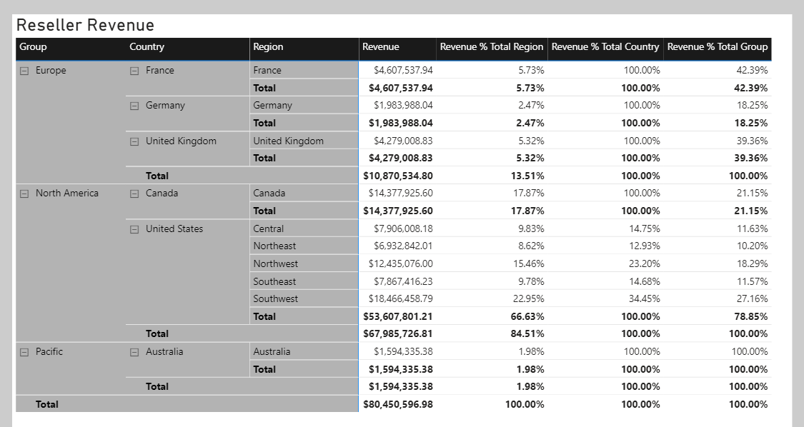
When you remove filters from the Region and Country columns in the Sales Territory table, the measure will calculate the region revenue as a ratio of its group's revenue.

Preserve filters
You can use the KEEPFILTERS DAX function as a filter expression in the CALCULATE function to preserve filters.
To observe how to accomplish this task, switch to Page 1 of the report. Then, modify the Revenue Red measure definition to use the KEEPFILTERS function.
DAX
Revenue Red =
CALCULATE(
[Revenue],
KEEPFILTERS('Product'[Color] = "Red")
)
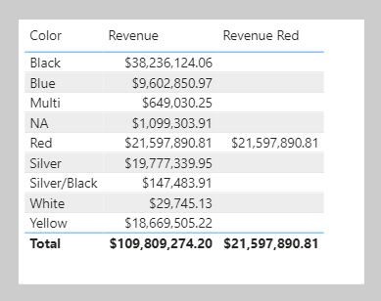
In the table visual, notice that only one Revenue Red value exists. The reason is because the Boolean filter expression preserves existing filters on the Color column in the Product table. The reason why colors other than red are BLANK is because the filter contexts and the filter expressions are combined for these two filters. The color black and color red are intersected, and because both can't be TRUE at the same time, the expression is filtered by no product rows. It's only possible that both red filters can be TRUE at the same time, which explains why the one Revenue Red value is shown.

Use inactive relationships
An inactive model relationship can only propagate filters when the USERELATIONSHIP DAX function is passed as a filter expression to the CALCULATE function. When you use this function to engage an inactive relationship, the active relationship will automatically become inactive.
Review an example of a measure definition that uses an inactive relationship to calculate the Revenue measure by shipped dates:
DAX
Revenue Shipped =
CALCULATE (
[Revenue],
USERELATIONSHIP('Date'[DateKey], Sales[ShipDateKey])
)

Modify relationship behavior
You can modify the model relationship behavior when an expression is evaluated by passing the CROSSFILTER DAX function as a filter expression to the CALCULATE function. It's an advanced capability.
The CROSSFILTER function can modify filter directions (from both to single or from single to both) and even disable a relationship.

Examine filter context
The VALUES DAX function lets your formulas determine what values are in filter context.
The VALUES function syntax is as follows:
DAX
VALUES(<TableNameOrColumnName>)
The function requires passing in a table reference or a column reference. When you pass in a table reference, it returns a table object with the same columns that contain rows for what's in filter context. When you pass in a column reference, it returns a single-column table of unique values that are in filter context.
The function always returns a table object and it's possible for a table to contain multiple rows. Therefore, to test whether a specific value is in filter context, your formula must first test that the VALUES function returns a single row. Two functions can help you accomplish this task: the HASONEVALUE and the SELECTEDVALUE DAX functions.
The HASONEVALUE function returns TRUE when a given column reference has been filtered down to a single value.
The SELECTEDVALUE function simplifies the task of determining what a single value could be. When the function is passed a column reference, it'll return a single value, or when more than one value is in filter context, it'll return BLANK (or an alternate value that you pass to the function).
In the following example, you will use the HASONEVALUE function. Add the following measure, which calculates sales commission, to the Sales table. Note that, at Adventure Works, the commission rate is 10 percent of revenue for all countries/regions except the United States. In the United States, salespeople earn 15 percent commission. Format the measure as currency with two decimal places, and then add it to the table that is found on Page 3 of the report.
DAX
Sales Commission =
[Revenue]
* IF(
HASONEVALUE('Sales Territory'[Country]),
IF(
VALUES('Sales Territory'[Country]) = "United States",
0.15,
0.1
)
)
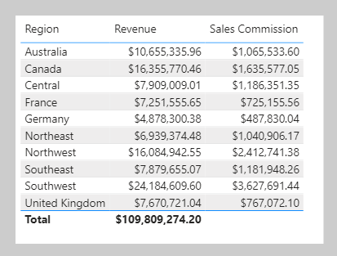
Notice that the total Sales Commission result is BLANK. The reason is because multiple values are in filter context for the Country column in the Sales Territory table. In this case, the HASONEVALUE function returns FALSE, which results in the Revenue measure being multiplied by BLANK (a value multiplied by BLANK is BLANK). To produce a total, you will need to use an iterator function, which is explained later in this module.
Three other functions that you can use to test filter state are:
- ISFILTERED - Returns TRUE when a passed-in column reference is directly filtered.
- ISCROSSFILTERED - Returns TRUE when a passed-in column reference is indirectly filtered. A column is cross-filtered when a filter that is applied to another column in the same table, or in a related table, affects the reference column by filtering it.
- ISINSCOPE - Returns TRUE when a passed-in column reference is the level in a hierarchy of levels.
Return to Page 2 of the report, and then modify the Revenue % Total Country measure definition to test that the Region column in the Sales Territory table is in scope. If it's not in scope, the measure result should be BLANK.
DAX
Revenue % Total Country =
VAR CurrentRegionRevenue = [Revenue]
VAR TotalCountryRevenue =
CALCULATE(
[Revenue],
REMOVEFILTERS('Sales Territory'[Region])
)
RETURN
IF(
ISINSCOPE('Sales Territory'[Region]),
DIVIDE(
CurrentRegionRevenue,
TotalCountryRevenue
)
)
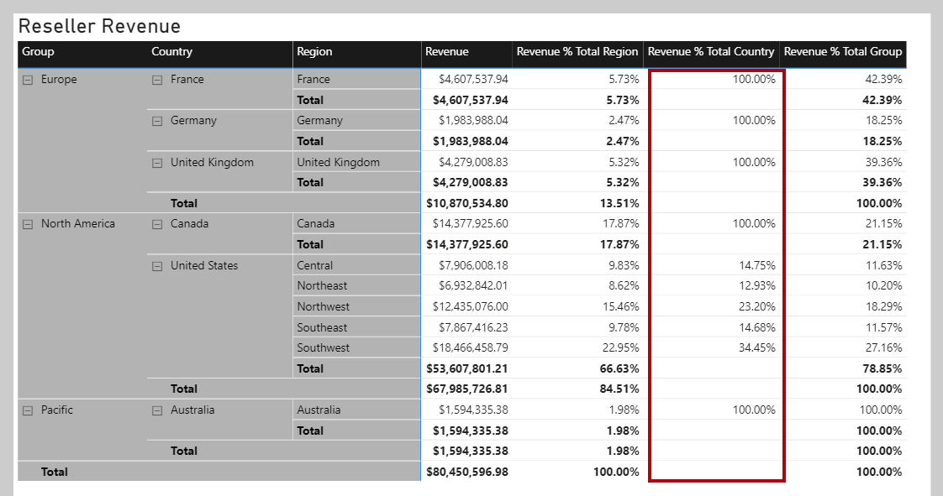
In the matrix visual, notice that Revenue % Total Country values are now only displayed when a region is in scope.

Perform context transition
What happens when a measure or measure expression is evaluated within row context? This scenario can happen in a calculated column formula or when an expression in an iterator function is evaluated.
In the following example, you will add a calculated column to the Customer table to classify customers into a loyalty class. The scenario is simple: When the revenue that is produced by the customer is less than $2500, the customer is classified as Low; otherwise they're classified as High.
DAX
Customer Segment =
VAR CustomerRevenue = SUM(Sales[Sales Amount])
RETURN
IF(CustomerRevenue < 2500, "Low", "High")
On Page 4 of the report, add the Customer Segment column as the legend of the pie chart.
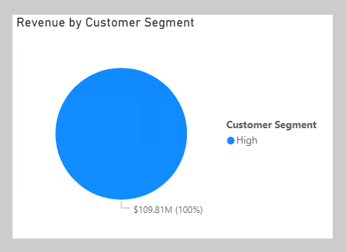
Notice that only one Customer Segment value exists. The reason is because the calculated column formula produces an incorrect result: Each customer is assigned the value of High because the expression SUM(Sales[Sales Amount]) isn't evaluated in a filter context. Consequently, each customer is assessed on the sum of every Sales Amount column value in the Sales table.
To force the evaluation of the SUM(Sales[Sales Amount]) expression for each customer, a context transition must take place that applies the row context column values to filter context. You can accomplish this transition by using the CALCULATE function without passing in filter expressions.
Modify the calculated column definition so that it produces the correct result.
DAX
Customer Segment =
VAR CustomerRevenue = CALCULATE(SUM(Sales[Sales Amount]))
RETURN
IF(CustomerRevenue < 2500, "Low", "High")
In the pie chart visual add the new calculated column to the Legend well, verify that two pie segments now display.
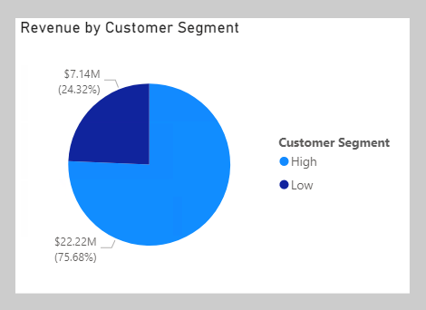
In this case, the CALCULATE function applies row context values as filters, known as context transition. To be accurate, the process doesn't quite work that way when a unique column is on the table. When a unique column is on the table, you only need to apply a filter on that column to make the transition happen. In this case, Power BI applies a filter on the CustomerKey column for the value in row context.
If you reference measures in an expression that's evaluated in row context, context transition is automatic. Thus, you don't need to pass measure references to the CALCULATE function.
Modify the calculated column definition, which references the Revenue measure, and notice that it continues to produce the correct result.
DAX
Customer Segment =
VAR CustomerRevenue = [Revenue]
RETURN
IF(CustomerRevenue < 2500, "Low", "High")
Now, you can complete the Sales Commission measure formula. To produce a total, you need to use an iterator function to iterate over all regions in filter context. The iterator function expression must use the CALCULATE function to transition the row context to the filter context. Notice that it no longer needs to test whether a single Country column value in the Sales Territory table is in filter context because it's known to be filtering by a single country/region (because it's iterating over the regions in filter context and a region belongs to only one country/region).
Switch to Page 3 of the report, and then modify the Sales Commission measure definition to use the SUMX iterator function:
DAX
Sales Commission =
SUMX(
VALUES('Sales Territory'[Region]),
CALCULATE(
[Revenue]
* IF(
VALUES('Sales Territory'[Country]) = "United States",
0.15,
0.1
)
)
)
The table visual now displays a sales commission total for all regions.
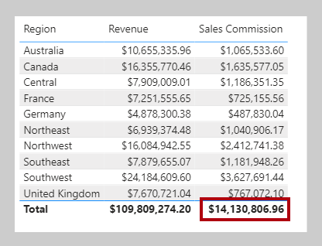

Knowledge check

Summary
In this module, you learned about filter context. You also learned why and how to work with the CALCULATE function to modify filter context by passing in filters. These filters can add or overwrite the filter context, and they can modify filter context when you are passing in special functions like REMOVEFILTERS or KEEPFILTERS. Additionally, you learned that the CALCULATE function can transition row context to filter context, which can be required when you are using measure expressions in calculated columns or iterator functions.

Use DAX time intelligence functions in Power BI Desktop models

